Inclusiveness Target Country (ITC) Application

Summary
Read me first 1
ITC Presentation 2
ITC application documents to prepare 3
Going to e-COST for applying 3
Grant awarding board (GAB) 4
ITC reporting and short report for dissemination purposes 5
ITC grant management 6
Annex I: e-COST link to application form template and our additional information template 8
Annex II: e-COST link to ITC report template and our dissemination information template 9

Read me first

The COST Action IMMUNO-model opens a call for applications for Inclusiveness Target Country (ITC) Conference Grants to be developed under the scope of the referred Action, in the terms described in this document in the ITC presentation chapter.

The call for Grant Period 3 (GP3) will cover November 3rd 2025 – April 30th 2026, both days included.

Application deadlines for this call
- November 3rd 2025 – April 30th 2026: Application for ITCs opens
- Applicants can submit their applications throughout this period
- Ongoing: selected candidates will be notified
- April 30th 2026: deadline for the conclusion of ITC activities, including ITC reports

Below is listed other information and links to procedures/regulations concerning ITCs
- Annotated Rules for COST Actions
- Grant Awarding – User Guide

Please consult the above documents before applying for the ITC. They can also be found here: https://www.cost.eu/funding/documents-guidelines/

The procedure is summarized as:
First step: read the chapter “ITC presentation” for general information
Second step: before applying prepare all the necessary documents. See the chapter “ITC application documents to prepare”.
Third step: applicants will go to the e-COST grant application. See the chapter “Going to e-COST for applying”.
Fourth step: after attending the Conference the applicant must upload on e-COST a report on the conference outcomes, a certificate of attendance, programme, a copy of the oral presentation, as well as a short report for publication in our COST Action website within 30 days after the end of the ITC. See the chapter “ITC reporting”.

ITC Presentation

Purpose of a ITC
ITC Conference grant funds an oral presentation of their own work within the scope of the Action by an IMMUNO-model Participant affiliated to a legal entity located in an Inclusiveness Target Country / Near Neighbour Country in a high-level conference fully organized by a third party, i.e. not organized nor co-organized by the COST Action:

ITC Conference grant:
- Serve COST Excellence and Inclusiveness Policy;
- Supports Action Participant affiliated to a legal entity located in an Inclusiveness Target Countries/ Near Neighbour Countries to establish a strong network and increase their visibility in the research community through sharing their work and to gain knowledge;
- Can contribute to increasing visibility of the Action.

ITC Conference grant benefits to:
- ITC Conference Grantee: receives support for attending and presenting their own work within the scope of the Action (oral presentation) in a conference and can establish new contacts for future collaborations.

The COST Inclusiveness Target Countries are : Albania, Armenia, Bosnia and Herzegovina, Bulgaria, Cyprus, Czech Republic, Estonia, Croatia, Georgia, Greece, Hungary, Lithuania, Latvia, Malta, Moldova, Montenegro, Poland, Portugal, Romania, Slovenia, Slovakia, Republic of North Macedonia, Republic of Serbia, Türkiye and Ukraine (for more details please see the COST Country and Organisations Table):

EU Member States | EU Member States Outermost Regions* | Full Members that are not EU Member States
Bulgaria, Croatia, Cyprus, Czech Republic, Estonia, Greece, Hungary5, Latvia, Lithuania, Malta, Poland, Portugal, Romania, Slovakia and Slovenia | French Guiana, Guadeloupe, Martinique, Mayotte, Reunion Island and Saint-Martin (France), Azores and Madeira (Portugal), and the Canary Islands (Spain) | Albania, Armenia, Bosnia and Herzegovina, Georgia, Moldova, Montenegro, North Macedonia, Serbia, Turkey, Ukraine
*It is important to note that for the participation of the network of proposers, the ITC status of researchers and innovators from EU Member States Outermost Regions will be counted as the EU Member State they are linked to. For example, researchers affiliated in a legal entity in e.g Guadeloupe will be counted as France (non-ITC), researchers affiliated in a legal entity in Azores will be counted as Portugal (ITC). Once the Action is approved, the researchers and innovators from these EU Member States Outermost Regions can benefit from the ITC status.

The COST Near Neighbour countries are: Algeria, Armenia, Azerbaijan, Belarus, Egypt, Jordan, Kosovo, Lebanon, Libya, Morocco, Palestine, Russia**, Syria, and Tunisia
** As of 6 May 2022 until further notice, measures are taken to suspend cooperation with Russia for the execution of the COST Actions and COST activities. Amongst these measures, participation and eligibility of COST Action participants affiliated to a legal entity established in Russia are suspended for all COST Actions and COST activities.

Eligibility Criteria

- The Grant applicant(s) are IMMUNO-model participants with a primary affiliation (see Article 4.1.1.1.1 on Annotated Rules for COST Actions) to a legal entity located in an ITC/NNC country;
- The Conference must be between November 3rd 2025 – April 30th 2026;
- The Core Group of the IMMUNO-model COST Action has decided to prioritize new applications. For this reason applicants that were already successful in Grant Period 3, cannot apply for another grant in this Grant Period 4.

Scope of IMMUNO-model COST Action

The IMMUNO-model COST Action aims at fostering research and innovation in the field of preclinical immuno-oncology models with the ultimate goal of advancing in the treatment of cancer patients by improving their outcomes and quality of life.

The unprecedented change that immunotherapy has represented in the treatment of cancer is best illustrated by the spectacular results obtained in previously incurable malignancies, such as metastatic melanoma. However, the widespread use of these therapies has been hindered by their limited effectiveness and associated toxicities. A better understanding on the complex interactions between tumor cells and the immune system is strictly required to address these problems, and to develop more effective and safer immunotherapies. However, one of the most important obstacles in immuno-oncology research is the scarcity of preclinical models that faithfully recapitulate human immunity and contribute to identify novel therapeutic targets, characterize biomarkers of therapeutic response and toxicity, and generate reliable data on drug synergies.

IMMUNO-model will bring together European researchers from diverse sectors (academia, clinical, industry) with the common goal of establishing a Network that endorses immuno-oncology research by specifically promoting the sharing, standardization and application of immunotherapy preclinical models. This Action will allow the implementation of a broad, creative and collaborative hub through the organization of community-building activities, the creation of synergies among European and non-European scientists, and the training of future researchers in the field. The ultimate aim of this Action is to contribute to translate novel scientific discoveries into benefits to cancer patients and the society.

For further details and specific objectives, please read the Memorandum of Understanding (MoU) of IMMUNO-model COST Action:
https://e-services.cost.eu/files/domain_files/CA/Action_CA21135/mou/CA21135-e.pdf.

The ITC should comply with the scope of the Action

ITC application documents to prepare

Grant Application – The template provided by COST to prepare your application can be found at https://www.cost.eu/ITCConference_GrantApplication

We request that the applicant fills in mandatory additional information in a separate form provided in Annex I to be uploaded separately when applying on e-COST. This additional information is mandatory to evaluate your proposal. If it is missing, the proposal will be rejected.

Acceptance (or invitation) letter from the conference organisers for the oral presentation.
It is responsibility of the applicant to obtain a written agreement from the Conference organizing committee. The letter must be dated back not more than 3 months.

A copy of the presentation.

Candidate CV.
A CV should be submitted, drafted preferably in Europass format (max. 3 pages). (A list of academic publications can be added on separate pages.)

Going to e-COST for applying

Application Procedure
The application procedure is legally bound to the Rules for COST Actions. Eligible ITC applicants must submit their ITC applications online by logging into e-COST (https://e-services.cost.eu) and go to https://e-services.cost.eu/activity/grants and click on “Apply for a grant”.

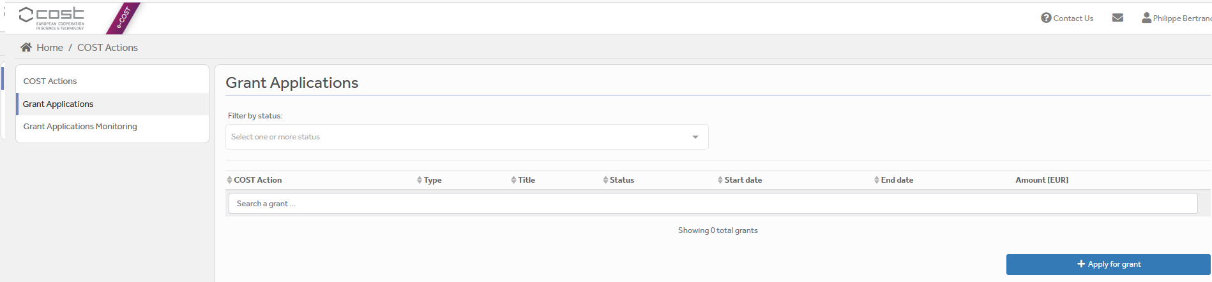

Then click on “Continue” on “ITC grant”, to encode a new application.
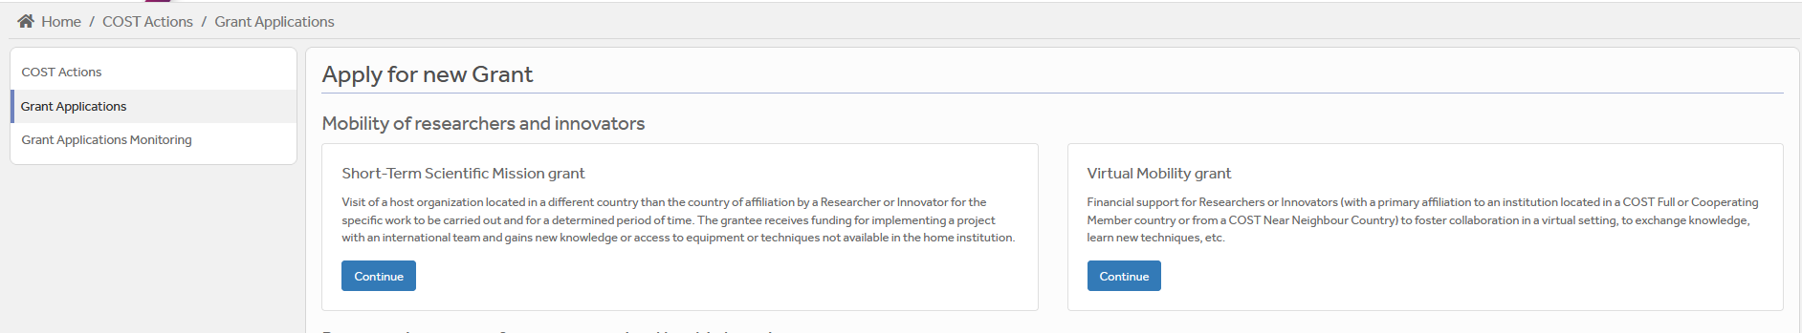

Then you just need to fill the online form with the following information:
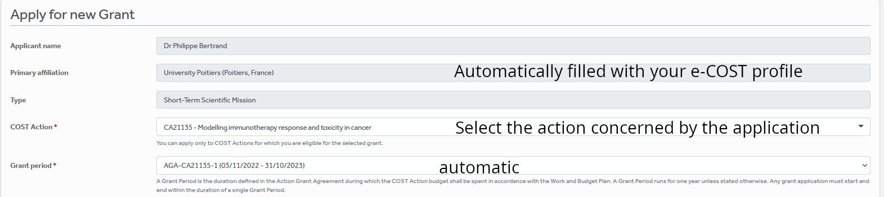
ITC

After “Save Draft” you reach the “Supporting documents” page. Here you need to mention the title of the file you will submit, the type and upload the file. Upload all the requested documents that includes:
- The Grant application form
- The Additional information document (Annex I)
- A CV
- Acceptance (or invitation) letter from the conference organisers for the oral presentation
- Copy of the abstract of the accepted oral presentation
- Material used for the communication.

Once all the documents are loaded, the applicant should click on “Submit”, a new window will appear and clicking on “Options”, please “download PDF”.

Grant awarding board (GAB)

The GAB is composed of the Grant Awarding Coordinator (Dr. Philippe Bertrand, Philippe.bertrand@univ-poitiers.fr) and representatives of the working groups. It is mandatory to select the working groups the application is related to in the additional information part of the modified grant application template as reviewers of the application will be selected in the same working group(s).
The GAB will perform the scientific assessment of the applications considering the IMMUNO-model Action scope and objectives, as well as the potential for enhancement of the research interaction between the involved parts, measured by the impact of the exchange expected by the applicants and involved institutions.
The selection of applicants is based on the scientific scope of the ITC application which must be coherent with the overall objectives of the Action. The GAB will select the successful applications.

In case of conflict of interest (i.e. the applicant belongs to a commission’s research group), the member that is constrained in their duties will be substituted by the Action Chair or the Vice-Chair.

General criteria for evaluation of ITC proposals are:
- Applicants must be from ITCs/NNCs;
- Gender balance;
- Quality of the communication material;
- Main expected networking activities during the conference and their contribution to the progress towards the Action objectives and deliverables;
- Curriculum Vitae (CV).
- Application between November 3rd 2025 – April 30th 2026;
- The Core Group of the IMMUNO-model COST Action has decided to prioritize new applications. For this reason applicants that were already successful in Grant Period 3, cannot apply for another grant in this Grant Period 4.

The Grant Holder Manager will inform each approved applicant by sending a Grant Letter generated from e-COST.

ITC reporting and short report for dissemination purposes

ITC report – The template provided by COST to prepare your application can be found at https://www.cost.eu/ITCConference_Report

Report for dissemination purposes (Annex II) We request the applicant to provide mandatory additional dissemination information in a separate form provided in Annex II to be uploaded separately on e-COST. This dissemination information is mandatory to approve the report. If it is missing, the report will be rejected.

The ITC report must be uploaded at the end of the ITC conference, within 30 days from the end date of the ITC and before April 30th 2026 via e-COST platform.

ITC Conference report

Other documents to be provided are:
- A certificate of attendance;
- The programme of the conference or book of abstracts / proceedings indicating the oral presentation of the grantee
- Copy of the oral presentation.
- The Additional information document (Annex II)

The networking report is drafted by the applicant (see Annex II).

When preparing the scientific report please consider the following:
- The networking report for COST is a public document. Please take this into account in terms of Intellectual Property Rights.
- The report should focus on the networking aspects, in particular how contacts for future collaborative research have been managed to strengthen the scientific relationship between the grantee and other people present at the conference within the framework of Cooperation and Science in the European Union.

The short report for dissemination purposes

Using Annex II, please provide a short blog / success story (3-4 sentences) /video (max. 1 minute) describing the subject of your collaborative ITC activities including a strong advertising sentence summarizing your ITC experience. This material will be used for promotion of our COST Action in our web site and social media. Also include all your credentials in social media (if you have any) to be able to tag you in when publishing your post.

Please remember to present your passion for science! Use pictures showing you at work but also after-work. Do not sound too abstract, avoid scientific jargon, use short sentences. The material is to advertise IMMUNO-model COST research, promote you, and will be shown in social media for public audience.

The material has to be sent directly to Working Group 5 Leader Barbara Breznik (barbara.breznik@nib.si) and to Working Group 5 Co-leader Rosalinda Sorrentino (rsorrentino@unisa.it) within 30 days after the end of your ITC and before April 30th 2026.

Failure to submit the scientific report & dissemination materials, and Host acceptance of the Report within 30 days from the end date of the ITC and before April 30th 2026 will effectively cancel the Grant.

By applying for this grant, the participant acknowledges that he/she is aware that his/her data and dissemination material will be collected, stored, processed and used for the purposes of the activities of the IMMUNO-model COST Action CA21135 in accordance with the General Data Protection Regulation (GDPR).

ITC grant management

Prepare your budget with the Excel tool provided in the modified Grant application template (Annex I). Each successful ITC applicant will be granted based on a fixed amount.

An ITC Grant is a fixed financial contribution which takes into consideration the budget request of the applicant and the outcome of the evaluation of the ITC application (max 2500 euros, virtual 500 euros). Please note that ITC Grants do not necessarily cover all expenses related to undertaking a given mission, being only a contribution to the overall travel, accommodation and meal expenses of the Grantee. Applicants are encouraged to evaluate their budget request based on a high benefit/cost ratio and justify it based on the perceived cost of living in the host country/city. Applicant should use the Excel tool provided in the modified Grant application form.

ITC grantees should make their own arrangements for all provisions related to personal security, health, taxation, social security and pension matters.

Grants are paid by the Grant Holder Institution after the completion of the activity and approval of all required report/documentation. Within 30 days from the end date of the ITC or before April 30th 2026, whichever date comes first), the successful applicant must submit the scientific report and the dissemination materials. These documents must be uploaded on e-COST to proceed with the request for payment.

ITC contacts

Dr. Philippe Bertrand  CA21135 Grant Awarding Coordinator  Institute of Chemistry for Media and Material  University of Poitiers  4 rue Michel Brunet TSA 51106  86073 Poitiers cedex 9  France  Philippe.bertrand@univ-poitiers.fr | Prof. Dr Leticia Oliveira-Ferrer  CA21135 Action Vice-Chair  Department of Gynecology  University Medical Center Hamburg-Eppendorf  Martinistrasse 52  20246 Hamburg  Germany  ferrer@uke.de

Annex I: e-COST link to application form template and our additional information template

A - Template to prepare the application: https://www.cost.eu/ITCConference_GrantApplication

B - Template for mandatory additional information to be filled in as a separate document and be uploaded on e-COST when applying.
Additional information requested by the Grant Awarding Board for the evaluation process. In case this information is not provided the application can be cancelled by the board.
Working groups in relation to the project [1] [2] [3] [4] [5] (select 2 max)
WG1 – In vitro and ex vivo cancer immunotherapy models
WG2 – In vivo cancer immunotherapy models.
WG3 – Solid tumors.
WG4 – Hematologic tumors
WG5 – Communication, events and partnering with industry.
For objectives of the working groups, please read the Memorandum of understanding: https://e-services.cost.eu/files/domain_files/CA/Action_CA21135/mou/CA21135-e.pdf.
Please include how the planned communication will contribute to the plan of one or more WG(s) of the Action.
Estimated budget plan: The applicant is requested to define a budget to explain the requested amount. An example is provided below for 1 month mission. The budget must consider shorter or longer stays. Asking 2000 euros for one week is not reasonable.
Double-click the table to edit the embedded excel sheet. Fill only greyed boxes. Current data are to illustrate the automatic calculation. (If not working contact Philippe.bertrand@univ-poitiers.fr)

Annex II: e-COST link to ITC report template and our dissemination information template

A - Template to prepare the report at : https://www.cost.eu/ITCConference_Report

B - Template for mandatory additional information to be filled in as a separate document and be uploaded on e-COST when reporting.

C - Mandatory dissemination information must be sent to Barbara Breznik (barbara.breznik@nib.si) and Rosalinda Sorrentino (rsorrentino@unisa.it)
The participant acknowledges that he/she is aware that his/her data and dissemination material will be collected, stored, processed and used for the purposes of the activities of the IMMUNO-model COST Action CA21135 in accordance with the General Data Protection Regulation (GDPR).

Expected dissemination information

Short blog / success story (3-4 sentences)
Pictures of grantee at the conference venue (examples are proposed below)
Credentials in social media (LinkedIn, X, Facebook), if applicable
Link to material to be downloaded (e.g. powerpoint, videos, links to network hub; pictures at high resolution…)

Examples of items for the dissemination information
  Add picture caption: Myself at Conference X…. |   Add caption: Myself giving a seminar/conference/in front of my poster…at Conference X…

