Book of Abstracts

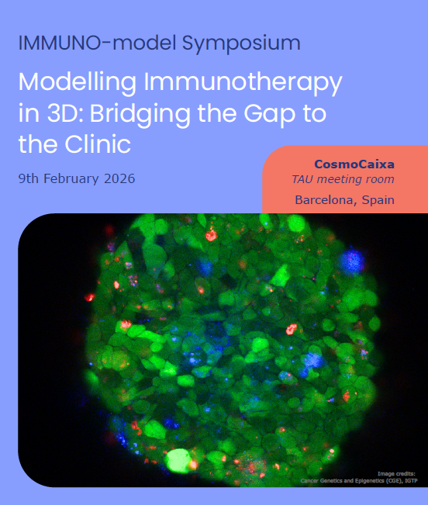



This Book of Abstracts is based upon work from COST Action IMMUNO-model CA21135 (https://www.immuno-model.eu/), supported by COST (European Cooperation in Science and Technology).
COST (European Cooperation in Science and Technology) is a funding agency for research and innovation networks. Our Actions help connect research initiatives across Europe and enable scientists to grow their ideas by sharing them with their peers. This boosts their research, career and innovation.

www.cost.eu

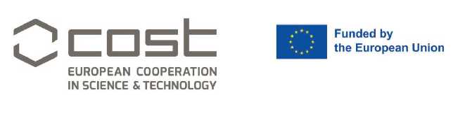

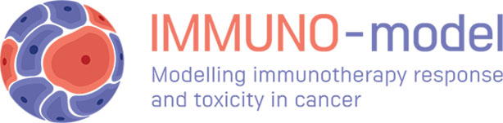

Scientific Program Committee
- Eva Martinez-Balibrea - Chair of IMMUNO-model COST Action, Germans Trias i Pujol Research Institute (IGTP) and Catalan Oncology Institute (ICO), Spain
- Vitor Gaspar – University of Aveiro, Portugal
- Ana Mitrovic - Jožef Stefan Institute, Slovenia
- Hatim Boughanem - Cordoba Institute for Biomedical Research (FIBICO), Spain

Local Organizing Committee
- Eva Martinez-Balibrea - Chair of IMMUNO-model COST Action, Germans Trias i Pujol Research Institute (IGTP) and Catalan Oncology Institute (ICO), Spain
- Arola Fortian - Germans Trias i Pujol Research Institute (IGTP), Spain
- Beatriz Gonzalez - Germans Trias i Pujol Research Institute (IGTP), Spain
- Sara Bystrup - Germans Trias i Pujol Research Institute (IGTP), Spain
- Ferran Grau - Germans Trias i Pujol Research Institute (IGTP), Spain
- Sergio Alonso - Germans Trias i Pujol Research Institute (IGTP), Spain
- Jordi Barretina – General Director, Germans Trias i Pujol Research Institute (IGTP) and Catalan Oncology Institute (ICO), Spain

https://www.immuno-model.eu/

Program

8:30 – 9:00 Registration
9:00 – 9:15 Session I Welcome
Eva Martinez-Balibrea, Chair of IMMUNO-model COST Action (Badalona, ES);
Jordi Barretina, IGTP Director (Badalona, ES).
Session I

Chairs: Sara Bystrup, Germans Trias i Pujol Research Institute (IGTP) (Badalona, ES) & Vitor Gaspar, University of Aveiro (Aveiro, PT).
9:15 – 9:35 Strength through diversity: Patient-derived organoids to dissect the heterogeneity of immune evasion in cancer
Krijn Dijkstra, The Netherlands Cancer Institute (Amsterdam, NL)
9:45 – 10:05 Immuno-Epithelioids: Preclinical in vitro modelling of immune–epithelial dynamics for immunotherapy development
David Fernandez-Antorán, IIS-Aragon (Zaragoza, ES) and The Gurdon Institute, University of Cambridge (Cambridge, UK)
10:15 – 11:00 Coffee break
11:00 – 11:20 Modelling Immunotherapy-Associated Toxicities in Human Autologous Immuno-Organoids
Lauriane Cabon, Roche Institute of Human Biology (Basel, CH)

Session II
Chairs: Arola Fortian, IGTP (Badalona, ES) & Ferran Grau, IGTP (Badalona, ES).
11:30 – 11:50 Multi-cellular models of the ovarian cancer microenvironment to study immunotherapies
Frances Balkwill, Centre for Tumour Microenvironment; Barts Cancer Institute, Queen Mary University of London (London, UK)
12:00 – 12:20 Tumor-on-Chip as a personalised immunocompetent platform for rapid drug testing
Maria Carla Parrini, Institut Curie - Inserm U1339 - CNRS UMR3666 (Paris, FR)
12:30 – 12:50 Modelling antitumour immune responses in human tumours to decode ICB clinical outcome
Mercedes Machuca-Ostos, The Netherlands Cancer Institute; Oncode Institute (Amsterdam, NL)
13:00 – 14:00 Lunch Break

Featured Talk
14:00 – 14:30 Modelling human tumour and tissue microenvironments using organoids
Calvin J Kuo, Stanford University School of Medicine (Palo Alto, USA)

Session III
Chairs: Hatim Boughanem, Cordoba Institute for Biomedical Research (FIBICO) (Cordoba, ES) & Beatriz Gonzalez, IGTP (Badalona, ES).
14:40 – 14:50 A Scalable 3D Ex Vivo Platform for Long-Term Immuno-Oncology Drug Screening in NSCLC.
Jens Kelm, CSO, PreComb AG, (Hombrechtikon, CH)
15:00 – 15:10 TBC - Industry Talk

Short Talks
15:20 – 15:35 Short Talk 1. Targeting HIF2α and PD-1 axes in patient-derived models of renal cancer
Maitane Márquez López, Biogipuzkoa Health Research Institute (San Sebastian, ES)
15:40 – 15:55 Short Talk 2. Establishing an Ovarian Cancer Patient AVATAR Using Malignant Ascites to Study Immunotherapy Approaches
Melissa Shahriari, University Medical Center Hamburg-Eppendorf (Hamburg, DE)
16:00 – 16:15 Short Talk 3. Microfluidic modelling of CAR-T cell trafficking and cytotoxic activity in solid tumours
Jack Zhang-Zhou, University of Zaragoza (Zaragoza, ES)
16:20 – 16:35 Short Talk 4. Exploring the Potential of BCG-Primed Anti-Tumour NK Cell Immunotherapy in 3D Preclinical Systems
Maria-Jose Felgueres, Spanish National Centre for Biotechnology (CNBCSIC), (Madrid, ES)

16:40 – 17:20 Round Table
Chairs: Eva Martinez-Balibrea, IGTP and Catalan Oncology Institute (ICO) (Barcelona, ES) & Sergio Alonso, IGTP (Badalona, ES).
17:20 – 17:30 Closing remarks
Eva Martinez-Balibrea, IGTP and ICO (Barcelona, ES).

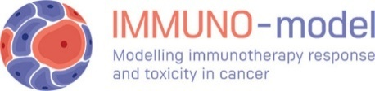

Speakers’ Abstract

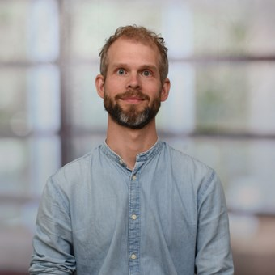
Dr. Krijn Dijkstra performs research bridging tumor immunology, organoid technology, and cancer evolution. His work focuses on understanding how cancer cells drive immune evasion in heterogeneous tumors, using patient-derived tumor organoid–immune cell co-culture systems to dissect interactions between cancer and the immune system. During his Ph.D. in the laboratory of Emile Voest and Ton Schumacher at the Netherlands Cancer Institute, he pioneered the use of tumor organoid - T cell co-cultures to determine the efficacy of cancer-immune interactions at the level of an individual patient (Cell 2018, Nature Protocols 2019, Nature Medicine 2020). As a postdoctoral fellow with Charles Swanton at the Francis Crick Institute, he investigated clonal evolution and subclonal immune escape in lung cancer, work recently published in Cancer Cell. He currently has his own independently funded research line at the Netherlands Cancer Institute to explore how cancer diversity and the secretome drive immune resistance.
Session I
Summary of the presentation. Strength through diversity: Patient-derived organoids to dissect the heterogeneity of immune evasion in cancer
A major barrier to effective cancer immunotherapy is the ability of tumors to evade immune destruction. While immune escape is often treated as a uniform tumor-wide property, growing evidence suggests it is instead shaped by cancer cell–intrinsic diversity and dynamic interactions with the tumor microenvironment. My work uses patient-derived organoids as functional models to dissect fundamental principles that underlie immune evasion in human cancers.
I will discuss two interconnected determinants of immune escape: intratumoral heterogeneity and the cancer cell secretome. First, using organoids derived from multi-region human lung tumors, I show that immune sensitivity is not uniform within a tumor but varies markedly between genetically distinct subclones. By functionally challenging clonal organoid sublines with T cells and natural killer cells, we find that immune-evasive and immune-sensitive clones can coexist within the same tumor, following distinct evolutionary trajectories and employing different modes of immune escape. These observations demonstrate that immune evasion is a subclonal and evolving phenotype, shaped by ongoing tumor evolution.
Second, I will describe how cancer cells actively remodel their secretome to shape anti-tumor immunity. Combining novel secretomics technologies with patient-derived colorectal cancer organoids, we uncover extensive rewiring of secreted factors during malignant transformation and identify cancer-specific secretory programs associated with immune exclusion. These findings highlight the secretome as a powerful cancer cell–intrinsic mechanism to modulate immune infiltration and function.
Looking ahead, I propose that subclonal differences in the secretome enable cooperative behavior and division of labor within tumors, allowing certain clones to create an immunosuppressive niche that benefits the tumor as a whole. By combining organoid-based immune co-cultures with high-resolution profiling of subclonal secretomes, this research seeks to reveal how heterogeneity and interclonal communication jointly drive immune evasion and therapeutic resistance.

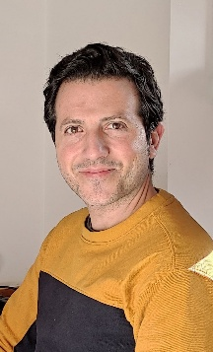
Dr. David Fernandez-Antorán I hold a PhD in molecular biology and immunology from the Spanish National Centre for Biotechnology (Madrid, Spain). During my postdoctoral research at the MRC Cancer Unit and Wellcome Sanger Institute (Cambridge, UK), I demonstrated that low doses of ionising radiation promote the expansion of pre-existing mutant p53 clones in normal tissues. This process can be reversed through external interventions, offering significant insights into mutational landscape evolution and tumour development, and suggesting potential strategies for cancer risk reduction through chemoprevention.
In 2020, I established my own research group as a CRUK RadNet Group Leader at The Gurdon Institute, University of Cambridge. My lab focuses on cell competition mechanisms and radiation biology, utilising an innovative in vitro 3D model called Epithelioids, which I developed. This model allows for the generation of trypsin-free, ultra-long-term primary cultures of both mouse and human normal and tumour epithelia, preserving the structure, cellular heterogeneity, and clonal composition of the original tissues.
I also serve as scientific deputy director of RadNet Cambridge and co-chair of the Emerging Radiotherapy Technologies national group.
In 2023, I obtained an ARAID Principal Investigator position and established a new laboratory at IIS-Aragon, Hospital Universitario Miguel Servet (Zaragoza, Spain), while continuing to lead my lab in Cambridge. This dual appointment has fostered strong scientific connections between Zaragoza and Cambridge, promoting new collaborations among researchers with shared scientific goals.

Summary of the presentation. Immuno-Epithelioids: Preclinical in vitro modelling of immune-epithelial dynamics for immunotherapy development
Alberto Pradilla-Dieste^{1,2}, Inês Ferreira^{1,2}, Jose Antonio Valverde-Lopez^{1,2}, Philippa Samella^{1,2}, Michelle Miniter^{1,2}, Ines Valencia-Diez³, David Fernandez-Antoran^{1,2,3,4*}
1The Gurdon Institute, University of Cambridge, Tennis Court Road, Cambridge CB2 1QN, UK
2Department of Pathology, University of Cambridge, Tennis Court Road, Cambridge, CB2 1QP, UK
3 Aragón Health Research Institute (IIS-Aragón), Av. San Juan Bosco 13, 50009, Zaragoza, Spain
4ARAID Foundation, Zaragoza, Spain
*corresponding author: df336@cam.ac.uk, df.antoran@iisaragon.es

To study disease mechanisms in humans, researchers mostly rely on ex vivo approaches. However, modelling tissue behaviour in vitro remains a major challenge, as many systems fail to fully recapitulate key in vivo features and their results are often difficult to translate to the clinic. Advances in complex 3D models, such as organotypic cultures and organoids, can nicely reproduce tissue architecture and several aspects of the original microenvironment, but they lack the self-maintaining capacity of adult tissues, limiting their use for long-term studies without passaging.
To address these limitations, we have developed an innovative in vitro system, “epithelioids”, which supports the long-term maintenance of 3D epithelial cultures derived from both mouse and human normal and tumour tissues. Epithelioids preserve structural organisation, cellular heterogeneity, and the dynamic behaviour of in vivo tissues, providing a robust and versatile platform to study human biology.
We have further optimised this technology to more accurately recapitulate the tissue microenvironment, allowing us to model not only tumour and normal tissue interactions but also the original immune infiltration effect during treatments. This approach offers a powerful platform to investigate the effects of chemotherapy, radiotherapy, and immunotherapy, and has strong potential as a tool for the optimisation and development of new therapeutic strategies.

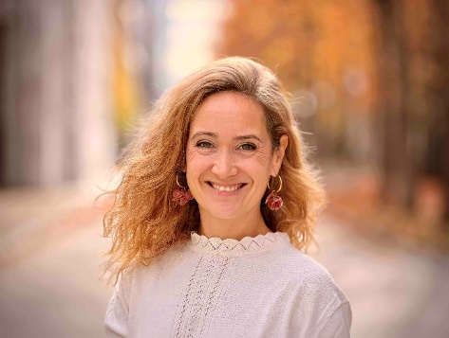
Dr. Lauriane Cabon, Group Lead, Roche Institute of Human Biology
Dr. Lauriane Cabon is the Group Lead for Applied Organoid Technologies at the Institute of Human Biology (IHB). Her research work sits at the intersection of bioengineering and immunology and focuses on translating advanced organoid-based models into robust, human-relevant assays to accelerate drug development. Previously, she led the development of 3D platforms for the preclinical assessment of immunotherapies at Roche (pRED) and held a postdoctoral fellowship at the Novartis Institutes for BioMedical Research. Lauriane holds degrees from Université Pierre et Marie Curie/INSERM, Ecole Normale Supérieure, and McGill University.

Summary of the presentation. Modeling Immunotherapy-Associated Toxicities in Human Autologous Immuno-Organoids
While stem cell-derived organoids have revolutionized our ability to model human epithelial biology, they traditionally lack the complex immune compartments essential for capturing organ-level pathologies and drug toxicities. In this presentation, I will describe our development of next-generation human immuno-organoid platforms that incorporate an autologous, tissue-resident immune compartment, spanning both innate and adaptive lineages.
First, I will present our recent published work regarding the establishment of human intestinal immuno-organoids (IIOs). By integrating adult tissue-resident memory T cells (TRMs) into epithelial organoids, we created a self-organizing system where immune cells continuously survey the epithelial barrier. We utilized this model to investigate the mechanisms of intestinal inflammation triggered by cancer-targeting biologics, identifying the Rho pathway as a potential target for mitigating immunotherapy-associated intestinal toxicity.
Expanding on this framework, I will share our latest findings on human lung alveolar immuno-organoids (LIOMs). These models incorporate autologous TRMs alongside an alveolar myeloid compartment. By simulating T-cell-mediated inflammation and analyzing data from the IMpower150 clinical trial, we demonstrate that this system can help model complex pulmonary side effects, such as checkpoint inhibitor-induced pneumonitis.
Together, these platforms provide a tractable, high-resolution human framework for studying tissue-resident immune responses and offer a powerful tool for the non-clinical safety profiling of immunotherapies before they reach the clinic.

Session II
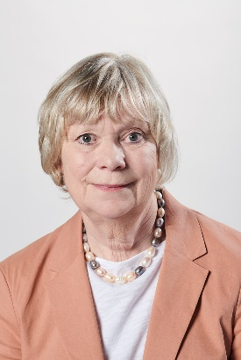
Professor Frances Balkwill OBE FMedSci FRS
Frances Balkwill is Professor of Cancer Biology at Barts Cancer Institute, Queen Mary University of London, and Deputy Centre Lead in the Centre for Tumour Microenvironment. She is especially interested in translating knowledge of cancer biology into new biological treatments for cancer. Much of her work focuses on the tumour microenvironment of ovarian cancer. After publishing a multi-level profile of the human ovarian cancer microenvironment, her lab developed a platform of new mouse models as well as human multi-cellular tissue culture models. They are now using these to research biological therapies that may prevent relapse and increase patient survival.
Fran is Director of Queen Mary’s Centre of the Cell, an informal biomedical science learning centre and outreach project in East London. There have been more than 275,000 participants in Centre of the Cell activities since opening in September 2009. Together with illustrator Mic Rolph, Fran has also produced thirteen science books for children on cell and molecular biology with titles such as Enjoy Your Cells, The Egg and Sperm Race and You, Me and HIV. These books have been translated into at least twelve foreign languages with over half a million copies sold worldwide.
Fran serves on CRUK, AIRC and Royal Society grant committees.
https://www.bartscancer.london/barts-cancer-institute/centre-for-tumour-microenvironment/
www.centreofthecell.org
Summary of the presentation. 3D multicellular models of the tumor microenvironment of ovarian cancer
High-grade serous ovarian cancer (HGSOC) is characterized by a complex, immunosuppressive tumor microenvironment (TME) that contributes to poor clinical outcomes and resistance to therapy. To understand better this TME we deconstructed omental metastases and then used this information as a template and validation for novel murine cancer models and 3D human cell models. To replicate the human TME in vitro, we are developing 3D multi-cellular models. Most recently we have developed a 3D pentaculture model incorporating five human cell types: malignant HGSOC cells and primary fibroblasts, mesothelial cells, adipocytes, monocytes. Monocytes differentiated into macrophages without exogenous cytokines in the pentacultures. Bulk RNA sequencing and deconvolution with single-cell RNA data from patient biopsies revealed that macrophage clusters within the pentacultures replicated those found in human HGSOC metastases, and proportions of individual clusters varied according to the malignant cell line. The pentacultures enabled detailed analysis of malignant cell–macrophage interactions and highlighted the influence of malignant cell genomic, transcriptomic and proteomic heterogeneity on the TME. Furthermore, targeting of “do-not-eat-me” signals with anti-CD47 and anti-CD24 monoclonal antibodies demonstrated differential effects on macrophage activity and cancer cell viability, again depending on the individual malignant cell line. Real-time microscopic monitoring of the pentacultures confirmed dynamic modulation of macrophage behavior. We conclude that this pentaculture model offers a platform to study malignant cell control of TME elements and their interactions with myeloid cells.

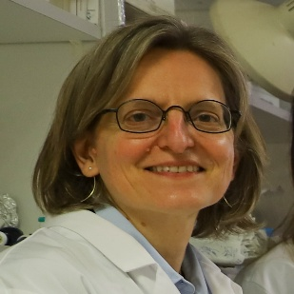
Dr. Maria Carla Parrini
Maria Carla Parrini, PhD, is a biologist with expertise in cancer cell biology. She received her doctoral degree from the University of Paris and subsequently pursued postdoctoral training at Harvard Medical School, Boston, USA, and at Osaka University, Japan. Since 2003, she works at the Institut Curie, Paris, where she pioneered the development and application of tumor-on-chip (ToC) technology.
Her research integrates cancer biology, bioengineering, and cell imaging to unravel how tumor ecosystems function and respond to therapies, including immunotherapies. From a precision oncology perspective, she is implementing patient-derived ToCs to enable personalized profiling of therapeutic response within a timeframe compatible with clinical decisions.
Dr. Parrini is co-author of approximately 60 peer-reviewed publications. She currently coordinates the European ARTURO project (2024–2028), which investigates how tumor-resident microbiota influence the response to anticancer treatments.

Summary of yhe presentation. "Tumor-on-Chip as a personalized immunocompetent platform for rapid drug testing"
Resistance to anti-cancer treatments remains a major challenge in clinical oncology, highlighting the need for innovative experimental approaches to model the tumor microenvironment (TME) and its response to therapies ex vivo. Tumor-on-chip (ToC) technology, part of the emerging field of Micro-Physiological Systems, offers an elegant and powerful solution to this problem. ToCs reconstitute the human TME in 3D inside microfluidic devices, with a precise control of experimental parameters.
Personalized ToCs are generated with autologous primary cells isolated from fresh tumor samples and are used to profile each patient's responses to drugs, including anti-PD-1 immunotherapy. A micro-engineered custom chip enables drug testing from a minimal amount of tumor biopsy material. In addition, ToCs recapitulate stromal-dependent resistance and allow its molecular mechanisms to be revealed. Importantly, ToCs generated from patient-derived xenografts (PDX) show strong concordance with PDX responses in vivo, supporting the potential value of integrating ToCs into clinical decision-making workflows in precision medicine.

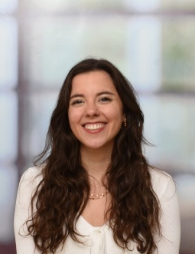
Dr. Mercedes Machuca-Ostos
She was born and raised in Sevilla, where she did my bachelor in Biomedical Sciences. To get a broader deeper view in Tumor Immunology, she performed a Double Degree Master in Maastricht (NL) and Kyoto (JP). Later, she joined the labs of Daniela Thommen and Lotje Zuur at the Netherlands Cancer Institute, where I am currently a senior PhD student working on the data to be discussed today.

Summary of the presentation. Modelling Immunotherapy-Associated Toxicities in Human Autologous Immuno-Organoids
Immune checkpoint blockade (ICB) has achieved striking results across multiple cancer types, but the mechanisms underlying these responses remain poorly understood. To delineate the immune dynamics upon ICB, we characterized the T cell dynamics of multiple longitudinal paired tumor and blood samples in combination with ex vivo models of ICB response. This analysis allowed to uncouple the treatment effects at the tumor site from systemic ones and revealed different immune landscapes responsible for driving responses in these patients, offering a comprehensive overview of the immunological events underpinning clinical outcomes to ICB.

Featured Talk
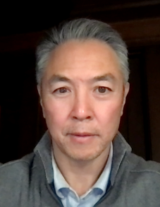
Professor Calvin J Kuo, Stanford University School of Medicine, Stanford, CA 94305 USA
Calvin Kuo MD, PhD is the Maureen Lyles D’Ambrogio Professor of Medicine at Stanford University School of Medicine. His research interests include development of complex human organoid models that co-preserve tumor or tissue epithelium en bloc with resident immune and stromal populations for study of tumor immunotherapy, autoimmunity and infectious disease. Other research areas include the biology of intestinal stem cell populations, and molecular regulation of angiogenesis and the blood-brain barrier.
Summary of the presentation. Organoid modeling of tumor and tissue microenvironments

Organoid culture is widely used to study normal and diseased human tissues. For disease modeling, organoids from normal tissues can be used to generate disease models, for instance by introduction of mutations or addition of pathogens. Alternatively, organoids can be directly generated from disease biopsies, which then allows study of pathophysiology, therapeutics modeling, and assessment of patient-specific responses. In our studies, we have developed methods to grow human organoids that preserve epithelial cells together with their endogenous stroma and immune populations. The application of these systems to study cancer immunobiology, autoimmunity and infectious disease will be discussed.

Session III


Dr. Jens Michael Kelm
Dr. Jens Michael Kelm is Chief Scientific Officer and co-founder of PreComb Therapeutics AG, Switzerland, with over 25 years of experience in 3D cell culture and organoid technologies for drug discovery and translational medicine. He co-founded InSphero AG, a pioneer in microtissue-based assays and organ-on-a-chip solutions, and has received multiple international awards for innovation. Dr. Kelm’s research focuses on physiologically relevant 3D tissue models to advance predictive toxicology, cancer research, and precision medicine. He has coordinated major European consortia (FP7, H2020), holds over 15 patents, and published 50+ peer-reviewed articles. He serves on the steering committee of the international 3D Cell Culture Conference and is actively translating organoid-based functional precision medicine into clinical applications.
Title of the presentation: A Scalable 3D Ex Vivo Platform for Long-Term Immuno-Oncology Drug Screening in NSCLC
Summary of the presentation. Together with the Medical University of Innsbruck we developed a scalable, automated 3D ex vivo platform for long-term screening of immuno-oncology drugs in NSCLC. Patient-derived microtumors generated over 21 days retained tumour and immune cell populations, enabling sustained monitoring of growth, T-cell activation, and cytokine dynamics. Responses were patient-specific, with measurable tumour regression and immune activation reflecting clinical outcomes. A clinical case for a triple combination including Keytruda highlights the predictive potential of the assay. This platform provides a high-throughput, patient-tailored tool for functional evaluation of ICIs and T-cell engagers, supporting therapy optimization and outcome prediction.

Exploring the Potential of BCG-Primed Anti-Tumour NK Cell Immunotherapy in 3D Preclinical Systems
Short Talks
Felgueres, Maria-Jose (mjelguerep@gmail.com)^{1§}, Muniesa-Martinez, Ines (inesmuniesa@gmail.com)^{1§}, Valés-Gómez, Mar (mvales@cnb.csic.es)^{*1}
§ These authors contributed equally to this work.
1 Department of Immunology and Oncology, National Centre for Biotechnology, Spanish National Research Council (CNB-CSIC), Madrid, Spain.
* Corresponding author.

Natural Killer (NK) cell-based immunotherapies hold great promise for treating solid tumours, but their clinical translation is limited by insufficient tumour infiltration and short in vivo persistence. We have developed a robust strategy to generate potent anti-tumour NK cells by priming peripheral blood mononuclear cells (PBMCs) with Bacillus Calmette-Guérin (BCG) followed by weekly stimulation with low doses of IL-12, IL-15, and IL-21. These BCG-induced lymphocytes (BIL-NK cells) expand up to 200-fold without cell sorting and display strong cytotoxicity against a variety of solid tumour targets. We established pilot studies using 3D bladder cancer spheroids and patient-derived colorectal cancer tumoroids to evaluate therapeutic efficacy of our BIL-NK cels. Confocal microscopy and immunohistochemistry demonstrated infiltration of BIL-NK cells into both models, while flow cytometry-based apoptosis assays confirmed target tumour cell killing. Importantly, these results were observed across different conditions for 3D model generation, highlighting the adaptability and potential of this approach for diverse tumour types. Moving forward, we aim to refine these models to continue exploring BIL-NK efficacy in additional organoid systems.

Targeting HIF2α and PD-1 axes in patient-derived models of renal cancer
Maitane Márquez^{1,2}, Bárbara Ibarzo^{#2}, Kok Haw Jonathan^{#2,3,4}, Charles Lawrie^{1,5,6} and Samra Turajlic^{2,7}
maitane.marquezlopez@bio-gipuzkoa.eus
¹Molecular Oncology Group, Biogipuzkoa Health Research Institute, San Sebastian, Spain, ²Cancer Dynamics Laboratory, The Francis Crick Institute, London, United Kingdom. ³Division of Cancer Sciences, The University of Manchester, Manchester, United Kingdom. ⁴Advanced Immune and Cell Therapy Team, The Christie NHS Foundation Trust, Manchester, United Kingdom. ⁵IKERBASQUE, Basque Foundation for Science, Bilbao, Spain ⁶Radcliffe Department of Medicine, University of Oxford, Oxford, United Kingdom. ⁷Skin and Renal Units, The Royal Marsden NHS Foundation Trust, London, United Kingdom.

Most patients with clear cell renal cell carcinoma (ccRCC) have somatic von Hippel-Lindau tumour suppressor (VHL) gene inactivation. The loss of VHL (pVHL) results in stabilization of hypoxia-inducible transcription factors (HIF1α and HIF2α), and consequently, in the activation of HIF-transcriptional targets involved in angiogenesis, cell cycle regulation and cellular metabolism. In the context of ccRCC, HIF2α has been proven to be the main modulator of oncogenesis. Therefore, there has been growing interest in exploring the therapeutic potential of inhibiting HIF2α in ccRCC. Previous studies have demonstrated that pVHL/HIF2α axis induce the expression of Programmed death-ligand 1 (PD-L1) in ccRCC, which highlights the potential synergy between checkpoint inhibitors and HIF2α inhibition. Current clinical trials are assessing this approach, where belzutifan (HIF2α antagonist) is being combined with pembrolizumab (PD-1 immune checkpoint inhibitor). Here, we investigated the effects of belzutifan and pembrolizumab, either as monotherapy or in combination, on the tumour microenvironment (TME) using patient-derived tumour fragments (PDTFs). PDTFs from nine treatment-naïve ccRCC patients were cultured for 48 h with each treatment, followed by immune profiling by flow cytometry and cytokine analysis by CBA. This study revealed significant immune heterogeneity in ccRCC, with enhanced immune activation observed in highly infiltrated patients following HIF2α inhibition and anti-PD-1 therapy. Our findings demonstrated an increased tumour-reactive T cells, immune activation, cytotoxicity, and proliferation markers in patient 8, indicating that this patient might be a responder to combination therapy, though this requires further confirmation. We concluded that baseline immune profiling and flow data after treatment, together with CBA assays must be integrated to predict immunotherapy response in ccRCC PDTFs.
Establishing an Ovarian Cancer Patient AVATAR Using Malignant Ascites to Study Immunotherapy Approaches
Melissa Shahriari¹, Franziska Brauneck², Jasmin Wellbrock², Maila Rossberg¹, Kathrin Eylmann¹, Carsten Bokemeyer², Barbara Schmalfeldt¹, Linda Diehl^{1#}, Leticia Oliveira-Ferrer^{1#}

¹Department of Gynecology, University Medical Center Hamburg-Eppendorf, Hamburg, Germany
² Department of Oncology, Hematology and Bone Marrow Transplantation with Section Pneumology, Hubertus Wald University Cancer Center, University Medical Center Hamburg-Eppendorf, Hamburg, Germany
# authors contributed equally.
Introduction: Ovarian cancer remains one of the most lethal gynecological malignancies, characterized by late diagnosis, intraperitoneal dissemination, and limited therapeutic options. While immune checkpoint inhibitors (ICIs) have demonstrated efficacy in multiple cancer entities, therapeutic responses in ovarian cancer are rather poor. This highlights the urgent need for physiologically relevant preclinical models that faithfully reflect the ovarian cancer tumor microenvironment (TME) and its interaction with the immune system. To address this challenge, we are developing patient-derived, three-dimensional “Ovarian Cancer Avatar” models using primary Malignant Ascites obtained during debulking surgery or ascites drainage at the University Medical Center Hamburg-Eppendorf (UKE). Malignant Ascites represents a clinically relevant source that contains both cellular and acellular tumor microenvironment components, including tumor cell aggregates (“spheroids”), single tumor cells, immune cells, and soluble factors.
Methods: Our aim is to establish culture conditions to preserve the original cellular composition and heterogeneity of the ascites, as well as the expression of key immune checkpoint molecules (ICM) enabling the evaluation of responses to immune checkpoint inhibitors (ICIs) alone or in combination. Our workflow includes: (i) phenotyping of the initial (d0) cell populations present in the ascites and (ii) assessment of immune checkpoint expression levels using multiparametric flow cytometry (mFC); (iii) cultivation of the samples in different media for six days; and (iv) a final (d6) comparative characterization of the viable cell populations and their expressed immune checkpoint molecules.
Results: Patient-derived ascites samples exhibited substantial inter-patient heterogeneity in both cellular composition and immune checkpoint expression profiles. Tumor cells were detected in almost all ascites samples, ranging, when present, from 1,3 to 13,5% and were predominantly contained within the aforementioned spheroids. Within the immune compartment, CD4+ T-cells were most abundant, followed by NK-cells and CD8+ T-cells. Several ICMs were expressed by CD4+ and CD8+ T-cells, NK and myeloid cells, with TIGIT and MARCO being expressed most frequently. Different media conditions showed distinct tendencies: Autologous ascites (M1) preferentially supported tumor cell maintenance and, in some cases, proliferation, whereas M1 medium supplemented with cytokines (IL-2, -7, -15 and CSF1) (M2) favored the preservation and expansion of immune cell populations, more closely recapitulating the original cellular composition. Despite pronounced inter-sample heterogeneity, immune checkpoint expression levels generally increased in M1, while M2 showed variable, modest changes, consistently remaining below the levels observed in ascites.
Conclusion: The resulting patient-derived avatar models recapitulate functionally relevant tumor-immune dynamics ex vivo, providing a platform for patient-specific assessment of responses to immune checkpoint blockade. In the long term, this approach offers a potential pathway toward more personalized and effective treatment strategies in ovarian cancer.

Microfluidic modelling of CAR-T cell trafficking and cytotoxic activity in solid tumours
Jack Zhang-Zhou^{1,2}, Carmen Oñate Salafranca³ , Maria del Valle Blazquez-Romero² , Patricia Balsas-Claveria² Maria Jose Gomez-Benito^{1,2} , Julian Pardo³ , Pedro E Guerrero⁴ and Jose Manuel Garcia-Aznar^{1,2,3}

(1) Aragon Institute of Engineering Research, Zaragoza, Spain, (2) University of Zaragoza, Zaragoza, Spain
(3) Aragon Institute for Health Research, Zaragoza, Spain, (4) University of Girona, Girona, Spain
Background. Chimeric Antigen Receptor T (CAR-T) cell therapy has demonstrated remarkable success in treating haematological malignancies, yet its efficacy in solid tumours remains limited due to the challenging tumour microenvironment [1]. This reduced effectiveness is largely attributed to physical infiltration barriers, as well as to the nutrient-deprived and hypoxic conditions within the tumour niche [2]. While biochemical factors have been extensively studied, the role of mechanical cues remains underexplored. To overcome this limitation, it is essential to investigate these mechanical mechanisms in physiologically relevant models to gain deeper insights into CAR-T cell functionality in solid tumours.
Methods. To replicate the biomechanical characteristics of solid tumours, we employed an innovative approach using microfluidic devices designed to mimic the tumour microenvironment [3]. These platforms were fabricated from polydimethylsiloxane (PDMS), a biocompatible silicone selected for its transparency, flexibility, and gas permeability [4]. CAR-T cells were seeded onto the microdevices and visualised via time-lapse microscopy for later processing and analysis using ImageJ and MATLAB software. CAR-T cell efficacy was further evaluated using transwell assays that simulated the spatial constraints and mechanical stress conditions typical of solid tumour tissues. These experiments were analysed via resazurin assay using a microplate reader in the corresponding emission range.
Results. We found that CAR-T cells present significant decrease in migration velocity and number of migrating cells under hypoglycaemic and hypoxic conditions - prevalent features of the tumour microenvironment. Furthermore, transwell migration experiments demonstrated that these immunotherapy cells show altered efficacy after undergoing physical stimuli. Therefore, these biomechanical constraints play a decisive role in immunotherapy against solid tumours.
Conclusions. Our results highlight that CAR-T cell migration, strongly related to correct infiltration in solid neoplasms, is remarkably influenced by mechanical cues under nutrient-deprived and hypoxic conditions. This methodology holds significant potential for future applications, including improved characterisation of CAR-T cell migration and the ability to predict infiltration efficiency in patient-specific contexts. Additionally, we present a simple yet effective way to examine how the biophysical environment alters CAR-T cells effectiveness, thereby contributing to the development of more effective immunotherapies for solid tumours.
This work was supported by the European Research Council (ERC) under the European Union’s Horizon 2020 research and innovation programme (ICoMICS grant agreement No 101018587).

Keywords: CAR T cells, Solid tumours, Tumour microenvironment
Ethics Approval. Human peripheral blood mononuclear cells (PBMCs) were collected and obtained from healthy donors and patients who provided informed consent, in accordance with protocols approved by the Ethical Committee of Clinical Research of Aragon, number: C.I.PI11/006.

References
[1] Newick K, O’Brien S, Moon E, Albelda SM. CAR T cell therapy for solid tumors. Annu. Rev. Med. 2017; 68: 139–152.
[2] Onozuka H, Tsuchihara K, Esumi H. Hypoglycemic/hypoxic condition in vitro mimicking the tumor microenvironment markedly reduced the efficacy of anticancer drugs. Cancer Sci. 2011; 102: 975-982.
[3] Zhang-Zhou J, Movilla Meno N, Oñate Salafranca C, Gomez-Benito MJ, Guerrero PE, Pardo Jimeno J, Garcia-Aznar JM. CAR-T cells are more affected than T lymphocytes by mechanical constraints: A microfluidic-based approach. Life Sci. 2025; 363: 123335.
[4] Shin Y, Han S, Jeon JS, Yamamoto K, Zervantonakis IK, Sudo R, Kamm RD, Chung S. Microfluidic assay for simultaneous culture of multiple cell types on surfaces or within hydrogels. 2012; 7: 1247-1259.
Acknowledgements.This work was supported by the European Research Council (ERC) under the European Union’s Horizon 2020 research and innovation programme (ICoMICS grant agreement No 101018587). Jack Zhang-Zhou was granted by the Ministerio de Educacion y Formacion Profesional (grant FPU21/06003).

