Dissemination Conference (DC) Application

Summary

Read me first 1
DC Presentation 2
DC application documents to prepare 3
Going to e-COST for applying 3
Grant awarding board (GAB) 4
DC reporting and short report for dissemination purposes 5
DC grant management 6
Annex I: e-COST link to application form template and our additional information template 7
Annex II: e-COST link to DC report template and our dissemination information template 8

Read me first

COST Action IMMUNO-model opens a call for applications for Dissemination Conference (DC) Grants to be developed under the scope of the referred Action, in the terms described in this document in DC presentation chapter.

The 2nd call for Grant Period 4 (GP4) will cover May 1st 2026 – October 31st 2026, both days included.

Application deadlines
- May 1st 2026 – October 1st 2026: Application for DCs opens
- Applicants can submit their applications throughout this period
- Ongoing: selected candidates will be notified
- October 1st 2026: deadline for applications to be submitted
- October 31st 2026: deadline for the conclusion of DC activities, including DC reports

Below are listed other information and links to procedures/regulations concerning DCs
- Annotated Rules for COST Actions
- Grant Awarding – User Guide

Please consult the above documents before applying for the DC. They can also be found here: https://www.cost.eu/funding/documents-guidelines/

The procedure is summarized as:
First step: read the chapter “DC presentation” for general information
Second step: before applying prepare all the necessary documents. See the chapter “DC application documents to prepare”.
Third step: applicants will go to the e-COST grant application. See the chapter “Going to e-COST for applying”.
Fourth step: after attending the Conference, the applicant must upload on e-COST a report on the conference outcomes, a certificate of attendance, programme of the Conference where the presentation is listed, a copy of the presentation, as well as a short report for publication in our COST Action website within 30 days after the end of the DC. See the chapter “DC reporting”.

DC Presentation

Purpose of a DC
Dissemination Conference (DC) grants consists in an oral presentation by an IMMUNO-model Participant of the work of the Action in high-level conferences fully organized by a third party, i.e. not organized nor co-organized by the COST Action:

Dissemination Conference:
- Significantly increase visibility of the Action in the research community, can contribute to increasing visibility of the presenter;
- Attract additional participants and stakeholders and disseminate Action results to relevant end-users at high profile conferences in the field on a topic relevant to the Action.

Dissemination Conference benefits to:
- Dissemination Conference Grantee: receives support for attending and delivering an oral presentation of the Action, their activities, results at a conference and for developing new contacts and potential future collaborations, actively networks with other participants and promotes the COST Action to the potential stakeholders;
- COST Action: receives increased visibility and awareness, new contacts with potential stakeholders.

Eligibility Criteria
- The Grant applicant(s) are IMMUNO-model participants with a primary affiliation (see Article 4.1.1.1.1 on Annotated Rules for COST Actions) to a legal entity located in a COST country;
- The Conference must be between May 1st 2026 – October 31st 2026;

Scope of IMMUNO-model COST Action
The IMMUNO-model COST Action aims at fostering research and innovation in the field of preclinical immuno-oncology models with the ultimate goal of advancing in the treatment of cancer patients by improving their outcomes and quality of life.
The unprecedented change that immunotherapy has represented in the treatment of cancer is best illustrated by the spectacular results obtained in previously incurable malignancies, such as metastatic melanoma. However, the widespread use of these therapies has been hindered by their limited effectiveness and associated toxicities. A better understanding on the complex interactions between tumor cells and the immune system is strictly required to address these problems, and to develop more effective and safer immunotherapies. However, one of the most important obstacles in immuno-oncology research is the scarcity of preclinical models that faithfully recapitulate human immunity and contribute to identify novel therapeutic targets, characterize biomarkers of therapeutic response and toxicity, and generate reliable data on drug synergies.
IMMUNO-model will bring together European researchers from diverse sectors (academia, clinical, industry) with the common goal of establishing a Network that endorses immuno-oncology research by specifically promoting the sharing, standardization and application of immunotherapy preclinical models. This Action will allow the implementation of a broad, creative and collaborative hub through the organization of community-building activities, the creation of synergies among European and non-European scientists, and the training of future researchers in the field. The ultimate aim of this Action is to contribute to translate novel scientific discoveries into benefits to cancer patients and the society. For further details and specific objectives, please read the Memorandum of Understanding (MoU) of IMMUNO-model COST Action:
https://e-services.cost.eu/files/domain_files/CA/Action_CA21135/mou/CA21135-e.pdf.

DC conferences should comply with the scope of the Action

DC application documents to prepare

Grant Application – The template provided by COST to prepare your application can be found at https://www.cost.eu/DisseminationConference_GrantApplication.

Acceptance (or invitation) letter from the conference organisers for the oral presentation.

Copy of the abstract of the accepted oral presentation

A copy of the presentation.

Candidate CV
A CV should be submitted, drafted preferably in Europass format (max. 3 pages). (A list of academic publications can be added on separate pages.)

Going to e-COST for applying

Application Procedure
The application procedure is legally bound to the Rules for COST Actions. Eligible DC applicants must submit their DC applications online by logging into e-COST (https://e-services.cost.eu) and go to https://e-services.cost.eu/activity/grants and click on “Apply for a grant”.

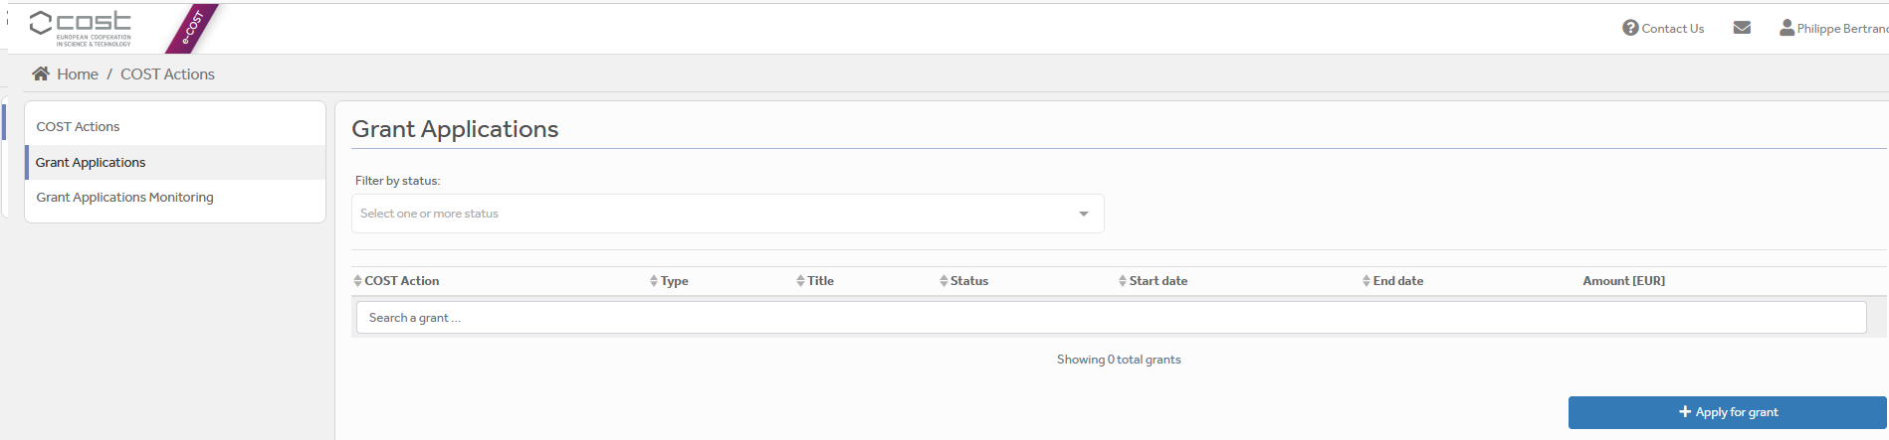

Then click on “Continue” on “DC grant”, to encode a new application.
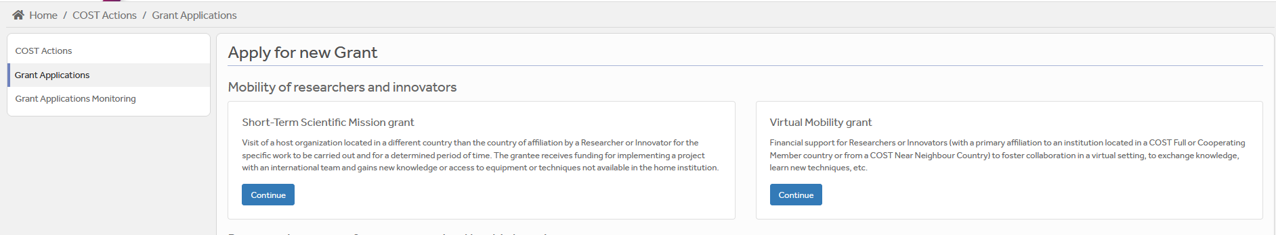

Then you just need to fill the online form with the following information:
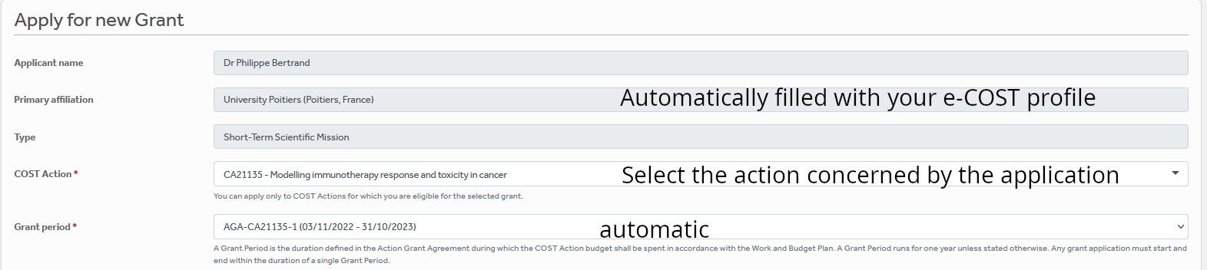
DC

After “Save Draft” you reach the “Supporting documents” page. Here you need to mention the title of the file you will submit, the type and upload the file. Upload all the requested documents that includes:
- The Grant application form modified,
- The Additional information document (Annex I)
- A CV,
- Letter of acceptance from the Conference Organizing Committee,
- Copy of the abstract of the accepted oral presentation
- Material used for the communication.

Once all the documents are loaded, the applicant should click on “Submit”, a new window will appear and clicking on “Options”, please “download PDF”.

Grant awarding board (GAB)

The GAB is composed of the Grant Awarding Coordinator (Dr. Philippe Bertrand, Philippe.bertrand@univ-poitiers.fr) and representatives of the working groups. It is mandatory to select the working groups the application is related to in the additional information part of the modified grant application template as reviewers of the application will be selected in the same working group(s).

The GAB will perform the scientific assessment of the applications considering the IMMUNO-model Action scope and objectives, as well as the potential for enhancement of the research interaction between the involved parts, measured by the impact of the exchange expected by the applicants and involved institutions.
The selection of applicants is based on the scientific scope of the DC application which must be coherent with the overall objectives of the Action. The GAB will select the successful applications.

In case of conflict of interest (i.e. applicant belonging to a commissioner’s research group), the member that is constrained in their duties will be substituted by the Action Chair or the Vice-Chair.

General criteria for evaluation of DC proposals are:
- Gender balance;
- Quality of the communication material;
- Main expected networking activities during the conference and their contribution to the progress towards the Action objectives and deliverables;

The Grant Holder Manager will inform each approved applicant by sending a Grant Letter generated from e-COST.

DC reporting and short report for dissemination purposes

DC report – The template provided by COST to prepare your application can be found at https://www.cost.eu/DisseminationConference_Report

Report for dissemination purposes (Annex II) We request the applicant to provide mandatory additional dissemination information in a separate form provided in Annex II to be uploaded separately on e-COST. This dissemination information is mandatory to approve the report. If it is missing, the report will be rejected.

DC Conference report

The report must be uploaded, within 30 days from the end date of the Conference and before October 31st 2026 via e-COST tool. Other documents to be provided are:
- A certificate of attendance;
- The programme of the conference or book of abstracts / proceedings indicating the oral presentation of the grantee
- A copy of the oral presentation
- The Additional information document (Annex II)

The networking report is drafted by the applicant (see Annex II).
When preparing the scientific report please consider the following:
- The networking report for COST is a public document. Please take this into account in terms of Intellectual Property Rights.
- The report should focus on the networking aspects, in particular how contacts for future collaborative research have been managed to strengthen the scientific relationship between the grantee and other people present at the conference within the framework of Cooperation and Science in the European Union.

DC dissemination report

Using Annex II, please provide a short blog / success story (3-4 sentences) /video (max. 1 minute) describing the subject of your collaborative DC activities including a strong advertising sentence summarizing your DC experience. This material will be used for promotion of our COST Action in our web site and social media. Also include all your credentials in social media (if you have any) to be able to tag you in when publishing your post.

Please remember to present your passion for science! Use pictures showing you at work but also after-work. Do not sound too abstract, avoid scientific jargon, use short sentences. The material is to advertise IMMUNO-MODEL COST research, promote you, and will be shown in social media for public audience.

The material has to be sent directly to Working Group 5 Leader Rosalinda Sorrentino (rsorrentino@unisa.it) within 30 days after the end of your DC and before October 31st 2026.

Failure to submit the Conference & dissemination report materials, certificate of attendance, presentation and book of the Conference within 30 days from the end date of the Conference and before October 31st 2026 will effectively cancel the Grant.

By applying for this grant, the participant acknowledges that he/she is aware that his/her data and dissemination material will be collected, stored, processed and used for the purposes of the activities of the IMMUNO-model COST Action CA21135 in accordance with the General Data Protection Regulation (GDPR).

DC grant management

Prepare your budget with the Excel tool provided in Annex I. Each successful DC applicant will be granted based on a fixed amount.
A DC Grant is a fixed financial contribution which takes into consideration the budget request of the applicant and the outcome of the evaluation of the DC application (max 2500 euros, virtual 500 euros). Please note that DC Grants do not necessarily cover all expenses related to undertaking a given mission, being only a contribution to the overall travel, accommodation and meal expenses of the Grantee. Applicants are encouraged to evaluate their budget request based on a high benefit/cost ratio and justify it based on the perceived cost of living in the host country/city. Applicant should use the Excel tool provided in the modified Grant application form.

DC grantees should make their own arrangements for all provisions related to personal security, health, taxation, social security and pension matters.

Grants are paid by the Grant Holder Institution after the completion of the activity and approval of all required report/documentation. Within 30 days from the end date of the DC Conference (or 15 days after the end of the Grant Period, whichever date comes first), the successful applicant must submit the Conference report, the dissemination materials, the programme/book of abstracts, copy of the oral presentation and the certificate of attendance. These documents must be uploaded on e-COST to proceed with the request for payment.

DC contacts

Dr. Philippe Bertrand  CA21135 Grant Awarding Coordinator  Institute of Chemistry for Media and Material  University of Poitiers  4 rue Michel Brunet TSA 51106  86073 Poitiers cedex 9  France  Philippe.bertrand@univ-poitiers.fr | Prof. Dr Leticia Oliveira-Ferrer  CA21135 Action Vice-Chair  Department of Gynecology  University Medical Center Hamburg-Eppendorf  Martinistrasse 52  20246 Hamburg  Germany  ferrer@uke.de

Annex I: e-COST link to application form template and our additional information template

A - Template to prepare the application: https://www.cost.eu/DisseminationConference_GrantApplication

B - Template for mandatory additional information to be filled in as a separate document and be uploaded on e-COST when applying.

Additional information requested by the Grant Awarding Board for the evaluation process. In case these information are not provided the application can be cancelled by the board.
Working groups in relation to the project [1] [2] [3] [4] [5] (select 2 max)
WG1 – In vitro and ex vivo cancer immunotherapy models
WG2 – In vivo cancer immunotherapy models.
WG3 – Solid tumors.
WG4 – Hematologic tumors
WG5 – Communication, events and partnering with industry.
For objectives of the working groups, please read the Memorandum of understanding: https://e-services.cost.eu/files/domain_files/CA/Action_CA21135/mou/CA21135-e.pdf.
Please include how the planned communication will contribute to the plan of one or more WG(s) of the Action.
Estimated budget plan: The applicant is requested to define a budget to explain the requested amount. An example is provided below for 1 month mission. The budget must consider shorter or longer stays. Asking 2000 euros for one week is not reasonable.
Double-click the table to edit the embedded excel sheet. Fill only greyed boxes. Current data are to illustrate the automatic calculation. (If not working contact Philippe.bertrand@univ-poitiers.fr)

Annex II: e-COST link to DC report template and our dissemination information template

A - Template to prepare the report at: https://www.cost.eu/DisseminationConference_Report

B - Template for mandatory additional information to be filled in as a separate document and be uploaded on e-COST when reporting.

C - Mandatory dissemination information must be sent to Rosalinda Sorrentino (rsorrentino@unisa.it)

The participant acknowledges that he/she is aware that his/her data and dissemination material will be collected, stored, processed and used for the purposes of the activities of the IMMUNO-model COST Action CA21135 in accordance with the General Data Protection Regulation (GDPR).

Expected information for dissemination
short blog / success story (3-4 sentences)
pictures of grantee at the conference venue
credentials in social media (LinkedIn, X, Facebook), if applicable
links to material to be downloaded (e.g. powerpoint presentation, videos, pictures at high resolution…)

Examples of items for the dissemination information
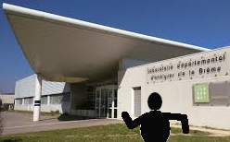  Add picture caption: Myself at Conference X…. |   Add caption: Myself giving a seminar/conference/in front of my poster…at Conference X…

