Short-Term Scientific Mission (STSM) Application

Summary
Read me first 1
STSM Presentation 2
STSM application documents to prepare 3
Going to e-COST for applying 3
Grant awarding board (GAB) 4
STSM reporting: Scientific Report, and short report for dissemination purposes 5
STSM grant management 6
Annex I: e-COST link to application form template and our additional information template 8
Annex II: e-COST link to STSM report template and our dissemination information template 9

Read me first

The COST Action IMMUNO-model opens a call for applications for Short-Term Scientific Missions (STSMs) to be developed under the scope of the referred Action, in the terms described in this document in the STSMs presentation chapter.

The 2nd call for Grant Period 4 (GP4) will cover May 1st 2026 – October 31st 2026, both days included.

Application deadlines for this call
- May 1st 2026 – October 1st 2026: Application for STSMs opens
- Applicants can submit their applications throughout this period
- Ongoing: selected candidates will be notified
- October 1st 2026: deadline for applications to be submitted
- October 31st 2026: deadline for the conclusion of STSM activities, including STSM reports

Below is listed other information and links to procedures/regulations concerning STSMs
- Annotated Rules for COST Actions
- Grant Awarding – User Guide

Please consult the above documents before applying for the STSM. They can also be found here: https://www.cost.eu/funding/documents-guidelines/

The procedure is summarized as:
First step: read the chapter “STSM presentation” for general information
Second step: before applying prepare all the necessary documents. See the chapter “STSM
application documents to prepare”.
Third step: applicants will go to e-COST grant application. See the chapter “Going to e-COST for
applying”.
Fourth step: after the mission is completed, the applicant must upload on e-COST a scientific report
approved by a scientist from the host institution as well as a short report for publication in our COST
action website within 30 days after the end of the STSM. See the chapter “STSM reporting”.

STSM Presentation

Purpose of a STSM

Short-Term Scientific Missions are visits of a researcher or innovator to a host organization located in a different country than the country of affiliation (for Affiliation, see Article 4.1.1.1.1 on Annotated Rules for COST Actions document) for specific work to be carried out and for a determined period of time. STSMs are valuable:

- for the STSM Grantee, who has the chance to receive funding for implementing a project with an international team, obtaining new knowledge or access to equipment or techniques not available in the home institution;
- for the STSM Host who can receive an international partner in their institution and extend or create a long-lasting collaboration. STSMs support specific / general topic(s) that can help achieve the Action MoU objectives and deliverables (research coordination). A STSM should specifically contribute to the scientific objectives of the COST Action, helping to achieve the Action MoU objectives and deliverables.

Eligibility Criteria

- The Grant applicant(s) are Action participants with a primary affiliation (see Article 4.1.1.1.1 in the Annotated Rules for COST Actions) to a legal entity located in a COST Full or Cooperating Member country, a COST Near Neighbour Country or a European RTD Organization;
- The Grant applicant is a researcher or innovator who visits a host organization located in a different country than the country of affiliation (for Affiliation, see Article 4.1.1.1.1 on Annotated Rules for COST Actions document) for specific work to be carried out and for a determined period of time;
- The STSM must have a minimum duration of 5 calendar days (including travel) and conclude between - May 1st 2026 – October 31st 2026;
- The COST Association and the Grant Holder of the Action cannot be considered as being an STSM grantee’s employer, i.e. the STSM Grant cannot be considered as a salary;

Scope of IMMUNO-model COST Action

The IMMUNO-model COST Action aims at fostering research and innovation in the field of preclinical immuno-oncology models with the ultimate goal of advancing in the treatment of cancer patients by improving their outcomes and quality of life.

The unprecedented change that immunotherapy has represented in the treatment of cancer is best illustrated by the spectacular results obtained in previously incurable malignancies, such as metastatic melanoma. However, the widespread use of these therapies has been hindered by their limited effectiveness and associated toxicities. A better understanding on the complex interactions between tumor cells and the immune system is strictly required to address these problems, and to develop more effective and safer immunotherapies. However, one of the most important obstacles in immuno-oncology research is the scarcity of preclinical models that faithfully recapitulate human immunity and contribute to identify novel therapeutic targets, characterize biomarkers of therapeutic response and toxicity, and generate reliable data on drug synergies.

IMMUNO-model will bring together European researchers from diverse sectors (academia, clinical, industry) with the common goal of establishing a Network that endorses immuno-oncology research by specifically promoting the sharing, standardization and application of immunotherapy preclinical models. This Action will allow the implementation of a broad, creative and collaborative hub through the organization of community-building activities, the creation of synergies among European and non-European scientists, and the training of future researchers in the field. The ultimate aim of this Action is to contribute to translate novel scientific discoveries into benefits to cancer patients and the society.

For further details and specific objectives, please read the Memorandum of Understanding (MoU) of IMMUNO-model COST Action:

https://e-services.cost.eu/files/domain_files/CA/Action_CA21135/mou/CA21135-e.pdf.

The STSM should comply with the scope of the action

STSM application documents to prepare

Grant Application – The template provided by COST to prepare your application can be found at https://www.cost.eu/STSM_GrantApplication.

We request that the applicant fills in mandatory additional information in a separate form provided in Annex I to be uploaded separately when applying on e-COST. This additional information is mandatory to evaluate your proposal. If it is missing, the proposal will be rejected.

Invitation letter from the Host Institution
It is the responsibility of the applicant to obtain a signed written agreement from the Host institution stating that the applicant may perform the activities detailed in the STSM working plan on the agreed dates. The letter must be dated back not more than 3 months, and must be signed by a permanent staff representative of the Host institution (e.g., head of the research group, PI, director of the department, head of the institute/division etc.)
The letter must include a statement from the host supervisor confirming the agreement to share the protocols used during the STSM in the IMMUNO-model Knowledge Hub (https://www.immuno-model.eu/activities/knowledge-hub/). If sharing is not possible, a detailed justification must be provided.

Candidate CV
A CV should be submitted, drafted preferably in Europass format (max. 3 pages). (A list of academic publications can be added on separate pages.)

Going to e-COST for applying

Application Procedure

The application procedure is legally bound to the Rules for COST Actions. Eligible STSM applicants must submit their STSM applications online by logging into e-COST (https://e-services.cost.eu) and go to https://e-services.cost.eu/activity/grants and click on “Apply for a grant”.
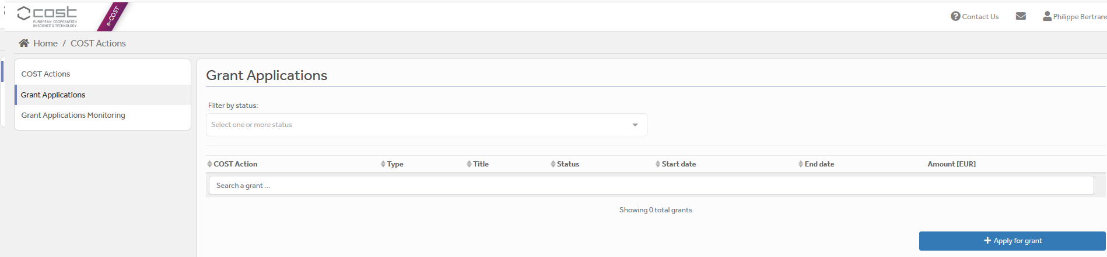

Then click on “Continue” on “Short-Term Scientific Mission grant”, to encode a new application.
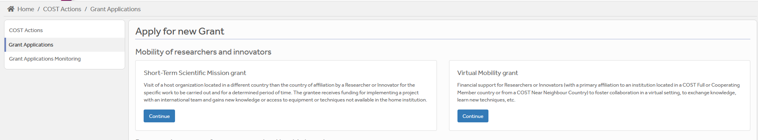

Then you just need to fill the online form with the following information:
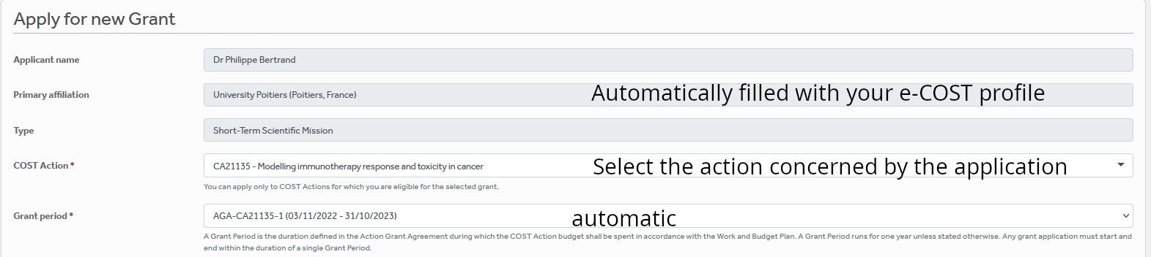

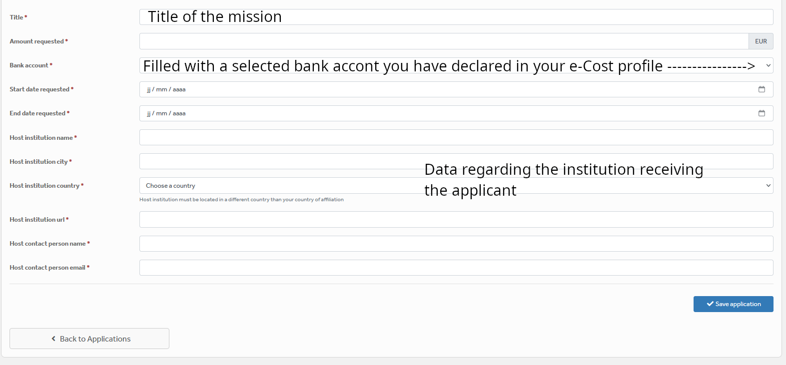

After “Save Draft” you reach the “Supporting documents” page. Here you need to mention the title of the file you will submit, the type and upload the file. Upload all the requested documents that includes:
- The Grant application form modified,
- A CV,
- Invitation letter from the Host, signed.

Once all the documents are loaded, the applicant should click on “Submit”, a new window will appear and clicking on “Options”, please “download PDF”.

Grant awarding board (GAB)

The GAB is composed of the Grant Awarding Coordinator (Dr. Philippe Bertrand, Philippe.bertrand@univ-poitiers.fr) and representatives of the working groups. It is mandatory to select the working groups the application is related to in the additional information part of the modified grant application template as reviewers of the application will be selected in the same working group(s).

The GAB will perform the scientific assessment of the applications considering the IMMUNO-model Action scope and objectives, as well as the potential for enhancement of the research interaction between the involved parts, measured by the impact of the exchange expected by the applicants and involved institutions.
The selection of applicants is based on the scientific scope of the STSM application which must be coherent with the overall objectives of the Action. The GAB will select the successful applications.

In case of conflict of interest (i.e. the applicant belongs to a commission’s research group), the member that is constrained in their duties will be substituted by the Action Chair or the Vice-Chair.

General criteria for evaluation of STSM proposals are:
- Priority to PhD students and post-docs until 2 years after the completion of the PhD.;
- Priority to applicants from ITCs;
- Gender balance;
- Clarity of activity planning (Working plan) and complementarity of resources between home and host institutions/research groups (resources are intended as: technical expertise, infrastructure, or instrumentation);
- Main expected results and their contribution to the progress towards the Action objectives and deliverables;
- Curriculum Vitae (CV).

The Grant Holder Manager will inform each approved applicant by sending a Grant Letter generated from e-COST.

STSM reporting: Scientific Report, and short report for dissemination purposes

STSM report – The template provided by COST to prepare your application can be found at https://www.cost.eu/STSM_Report.

Letter of approval of the STSM report by the Host Institution

Report for dissemination purposes (Annex II) We request the applicant to provide mandatory additional dissemination information in a separate form provided in Annex II to be uploaded separately on e-COST. This dissemination information is mandatory to approve the report. If it is missing, the report will be rejected. Shared protocols should be added in this dissemination information report.

The STSM report must be approved by the host supervisor and uploaded at the end of the STSM, within 30 days from the end date of the STSM and before October 31st 2026 via e-COST platform. Host approval of the scientific report is an official letter / email from a senior Researcher affiliated to the Host institution formally stating the acceptance of the scientific report. Once approved by the host supervisor, the report must be uploaded on e-COST.

The scientific report is drafted by the applicant (max 4 pages).

When preparing the scientific report please consider the following:
- The scientific report for COST is a public document. Please take this into account in terms of Intellectual Property Rights.
- The scientific report does not need to contain specific and detailed results of the research. Rather, it should focus on the aspects that are the aim of STSM (see Purpose of a STSM, page 2 of this Call), in particular how the collaborative research during STSM has strengthened the scientific relationship between Home and Hosting institutions within the framework of Cooperation and Science in the European Union.

The short report for dissemination purposes

Using Annex II, please provide a short blog / success story (3-4 sentences) /video (max. 1 minute) describing the subject of your collaborative STSM activities including a strong advertising sentence summarizing your STSM experience. This material will be used for promotion of our COST action in our web site and social media.
Also include all your credentials in social media (if you have any) to be able to tag you in when publishing your post.

Please remember to present Home and Host institutions and your passion for science! Use pictures showing you at work but also after-work. Do not sound too abstract, avoid scientific jargon, use short sentences. The material is to advertise IMMUNO-model COST research, promote you, and will be shown in social media for public audience.

The material has to be sent directly to Working Group 5 Leader Rosalinda Sorrentino (rsorrentino@unisa.it) within 30 days after the end of your STSM and before October 31st 2026.

Failure to submit the scientific report & dissemination materials, and Host acceptance of the Report within 30 days from the end date of the STSM and before October 31st 2026 will effectively cancel the Grant.

By applying for this grant, the participant acknowledges that he/she is aware that his/her data and dissemination material will be collected, stored, processed and used for the purposes of the activities of the IMMUNO-model COST action CA21135 in accordance with the General Data Protection Regulation (GDPR).

STSM grant management

Prepare your budget with the Excel tool provided in the Template for mandatory additional information (Annex I.B). Each successful STSM applicant will be granted a sum based on the duration of their stay. We recommend that the requested grant does not exceed 1,000 euros for 1 week and 2,500 euros for one month, and has to be justified with the excel sheet provided.

*Please note, that in compliance with the Annotated Rules (page 100) the maximum amount that may be reimbursed is up to EUR 4,000 per grant.

An STSM Grant is a fixed financial contribution which takes into consideration the budget request of the applicant and the outcome of the evaluation of the STSM application. Please note that STSM Grants do not necessarily cover all expenses related to undertaking a given mission, being only a contribution to the overall travel, accommodation and meal expenses of the Grantee. Applicants are encouraged to evaluate their budget request based on a high benefit/cost ratio and justify it based on the perceived cost of living in the host country/city. Applicant should use the Excel tool provided in the modified Grant application form.

STSM grantees should make their own arrangements for all provisions related to personal security, health, taxation, social security and pension matters.

Grants are paid by the Grant Holder Institution after the completion of the activity and approval of all required report/documentation. Within 30 days from the end date of the STSM (or 15 days after the end of this first STSM call for this Grant Period, whichever date comes first), the successful applicant must submit the scientific report, the dissemination materials and the approval letter of the scientific report from the Host institution. These documents must be uploaded on e-COST to proceed with the request for payment.

Pre-payment
STSMs grantees may request up to 50% pre-payment of the approved grant. This amount is subject to availability of funds and approval by the Grant Holder Institution. The request of pre-payment shall be submitted to the Grant Holder Manager (ghm_immunomodel@igtp.cat) and the Grant Awarding Coordinator (Dr. Philippe Bertrand, Philippe.bertrand@univ-poitiers.fr).

STSM contacts

Dr. Philippe Bertrand  CA21135 Grant Awarding Coordinator  Institute of Chemistry for Media and Material  University of Poitiers  4 rue Michel Brunet TSA 51106  86073 Poitiers cedex 9  France  Philippe.bertrand@univ-poitiers.fr | Prof. Dr Leticia Oliveira-Ferrer  CA21135 Action Vice-Chair  Department of Gynecology  University Medical Center Hamburg-Eppendorf  Martinistrasse 52  20246 Hamburg  Germany  ferrer@uke.de

Annex I: e-COST link to application form template and our additional information template

A - Template to prepare the application: https://www.cost.eu/STSM_GrantApplication

B - Template for mandatory additional information to be filled in as a separate document and be uploaded on e-COST when applying.
Additional information requested by the Grant Awarding Board for the evaluation process. In case these information is not provided the application can be cancelled by the board.
Working groups in relation to the project [1] [2] [3] [4] [5] (select a maximum of 2 working groups)
WG1 – In vitro and ex vivo cancer immunotherapy models
WG2 – In vivo cancer immunotherapy models.
WG3 – Solid tumors
WG4 – Hematologic tumors
WG5 – Communication, events and partnering with industry.

For objectives of the working groups, please read the Memorandum of understanding: https://e-services.cost.eu/files/domain_files/CA/Action_CA21135/mou/CA21135-e.pdf.

Please include how the planned activities will contribute to the plan of one or more WG(s) of the Action.

Synopsis of current work and experience: Explain here how your current work and experience and those from the hosting institution allows you to achieve the goals of the mission.
- How your STSM project will impact/benefit your current research project.
- How your current research skills will be used during the planned work.
- Which technics at your home institution will be transferable to the STSM project at the host institution and/or vice versa.

Estimated budget plan: The applicant is requested to define a budget to explain the requested amount. An example is provided below for 1 month mission. The budget must consider shorter or longer stays. Asking 2000 euros for one week is not reasonable.
Double-click the table to edit the embedded excel sheet. Fill only greyed boxes. Current data are to illustrate the automatic calculation. (If not working contact Philippe.bertrand@univ-poitiers.fr)
Intellectual Property Rights concerns
In case of potential intellectual property concerns, by the host and/or HOME institutions, must be mentioned in the application and managed by IP teams from host and/or HOME institutions. In this case the reviewers of the application may be requested to sign a confidential agreement. If no IP concerns apply, please mention in your application that there are no IP concerns.

Annex II: e-COST link to STSM report template and our dissemination information template

A - Template to prepare the report at : https://www.cost.eu/STSM_Report

B - Template for mandatory additional information to be filled in as a separate document and be uploaded on e-COST when reporting.
Charts or figures of some experimental results (if not confidential). They could be in the regular e-COST report.
Add experimental protocol to be published in the knowledge hub of the action (if agreement stated in the invitation letter from host). The template for preparing a protocol is available at this link: [link]

C - Mandatory dissemination information must be sent to Rosalinda Sorrentino (rsorrentino@unisa.it)
Short report for dissemination purposes.
The participant acknowledges that he/she is aware that his/her data and dissemination material will be collected, stored, processed and used for the purposes of the activities of the IMMUNO-model COST action CA21135 in accordance with the General Data Protection Regulation (GDPR).

Expected dissemination information
Short blog / success story (3-4 sentences)
Short video (1-2 mn) taken in the host lab with local team (link to the material)
Pictures of grantee in the host lab (examples are proposed below) (link to the material)
Credentials in social media (LinkedIn, X, Facebook), if applicable
Shared protocols
Examples of pictures to add
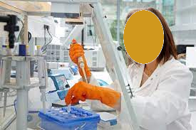  Add picture caption: Who is doing what and where | 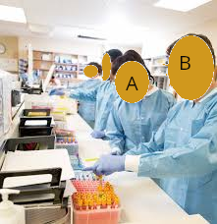  Add picture caption: A and B doing something at…Could be out of lab.
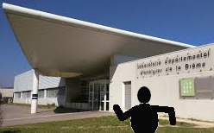  Add picture caption: Myself at institution X…. |   Add caption: Myself giving a seminar/conference/in front of my poster…at …

