Virtual Mobility (VM) Grant Application

Summary
Read me first 1
VM Presentation 2
VM application documents to prepare 3
Going to e-COST for applying 3
Grant awarding board (GAB) 4
VM reporting: Scientific Report, and short report for dissemination purposes 5
VM grant management 6
Annex I: e-COST link to application form template and our additional information template 8
Annex II: e-COST link to VM report template and our dissemination information template 9

Read me first

The COST Action IMMUNO-model opens a call for applications for Virtual Mobility (VM) Grants to be developed under the scope of the referred Action, in the terms described in this document in the VM presentation chapter.

The 2nd call for Grant Period 4 (GP4) will cover May 1st 2026 – October 31st 2026, both days included.

Application deadlines for this call
- May 1st 2026 – October 1st 2026: Application for VMs opens
- Applicants can submit their applications throughout this period
- Ongoing: selected candidates will be notified
- October 1st 2026: deadline for applications to be submitted
- October 31st 2026: deadline for the conclusion of VM activities, including VM reports

Below is listed other information and links to procedures/regulations concerning VMs
- Annotated Rules for COST Actions
- Grant Awarding – User Guide

Please consult the above documents before applying for the VM. They can also be found here: https://www.cost.eu/funding/documents-guidelines/

The procedure is summarized as:
First step: read the chapter “VM presentation” for general information
Second step: before applying prepare all the necessary documents. See the chapter “VM application documents to prepare”.
Third step: applicants will go to the e-COST grant application. See the chapter “Going to e-COST for applying”.
Fourth step: after the mission is completed applicant must upload on e-COST a report on the VM outcomes and any links to numeric materials, as well as a short report for publication in our COST Action website within 30 days after the end of the VM. See the chapter “VM reporting”.

VM Presentation

Purpose of a VM
Virtual Mobility (VM) Grants are grants awarded to IMMUNO-model participants for supporting activities aiming at capacity building and transfer of knowledge through bilateral/multilateral collaborations in a virtual setting.

Scope of the VM Grants

The activities expected to be performed by the successful applicant, but not limited to, are:
- Virtual mentoring schemes, with special focus on activities and exchanges that can generate capacity building and new skills, particularly for Young Researchers and Investigators (e.g. managerial skills, methodological skills, communication skills, etc).
- To support the implementation of research related activities that do not necessarily require in-person presence, e.g.
  - computational or modelling activities.
  - data analysis of the Action for a specific report or activity.
  - write-up of joint research articles.
- To support the harmonisation and standardisation of methods and procedures within the Action networking activities, e.g.
  - setting up a survey amongst all Action members to collect different results and outcomes from experiments done in their respective labs and research groups.
  - coordinating the discussions to create common protocols to be used by the network afterwards.
  - preparing questionnaires and response scales to be used by the Action members as part of virtual networking activities.
- Content preparation and coordination of science communication activities, e.g.
  - Massive Online Open Courses (MOOC).
  - Online workshops like 'webinar series' or 'tv series'-like format.
  - Online COST Action workshops in external international conferences or events, when the applicant can demonstrate a role in the organising committee, that could help in the promotion of the Action activities.
VM Grants should contribute to the scientific objectives of IMMUNO-model COST Action, and respect COST policies with particular attention on inclusiveness and excellence. The main aim and objective of the Action is to integrate and strengthen capacity in burden of disease assessment across Europe and beyond. Please refer to the Action aims and objectives for further details.

Eligibility Criteria

- The Grant applicant(s) are IMMUNO-model participants with a primary affiliation (see Article 4.1.1.1.1 on Annotated Rules for COST Actions) to a legal entity located in in a COST Full or Cooperating Member country, a COST Near Neighbour Country or a European RTD Organization;
- The Grant applicant is a researcher or innovator who develops virtual tools contributing to the IMMUNO-model MoU.
- The VM Grant must conclude between May 1st 2026 – October 31st 2026
- Applicants receiving a grant in one GP may reapply in the next GP if the continuity of the project is necessary throughout the duration of the IMMUNO-model Action.

Scope of IMMUNO-model COST Action

The IMMUNO-model COST Action aims at fostering research and innovation in the field of preclinical immuno-oncology models with the ultimate goal of advancing in the treatment of cancer patients by improving their outcomes and quality of life.

The unprecedented change that immunotherapy has represented in the treatment of cancer is best illustrated by the spectacular results obtained in previously incurable malignancies, such as metastatic melanoma. However, the widespread use of these therapies has been hindered by their limited effectiveness and associated toxicities. A better understanding on the complex interactions between tumor cells and the immune system is strictly required to address these problems, and to develop more effective and safer immunotherapies. However, one of the most important obstacles in immuno-oncology research is the scarcity of preclinical models that faithfully recapitulate human immunity and contribute to identify novel therapeutic targets, characterize biomarkers of therapeutic response and toxicity, and generate reliable data on drug synergies.

IMMUNO-model will bring together European researchers from diverse sectors (academia, clinical, industry) with the common goal of establishing a Network that endorses immuno-oncology research by specifically promoting the sharing, standardization and application of immunotherapy preclinical models. This Action will allow the implementation of a broad, creative and collaborative hub through the organization of community-building activities, the creation of synergies among European and non-European scientists, and the training of future researchers in the field. The ultimate aim of this Action is to contribute to translate novel scientific discoveries into benefits to cancer patients and the society.

For further details and specific objectives, please read the Memorandum of Understanding (MoU) of IMMUNO-model COST Action:

https://e-services.cost.eu/files/domain_files/CA/Action_CA21135/mou/CA21135-e.pdf.
The VM should comply with the scope of the Action
VM application documents to prepare

Grant Application – The template provided by COST to prepare your application can be found at https://www.cost.eu/virtual_mobility_grant_application

We request that the applicant fills in mandatory additional information in a separate form provided in Annex I to be uploaded separately when applying on e-COST. Because VM are virtual mission the proposed budget (if any) will not contain travel and accommodation costs but only costs that could be necessary for the networking activities. This additional information is mandatory to evaluate your proposal. If it is missing, the proposal will be rejected.

Candidate CV
A CV should be submitted, drafted preferably in Europass format (max. 3 pages). (A list of academic publications can be added on separate pages.)

Going to e-COST for applying

Application Procedure

The application procedure is legally bound to the Rules for COST Actions. Eligible VM applicants must submit their VM applications online by logging into e-COST (https://e-services.cost.eu) and go to https://e-services.cost.eu/activity/grants and click on “Apply for a grant”.
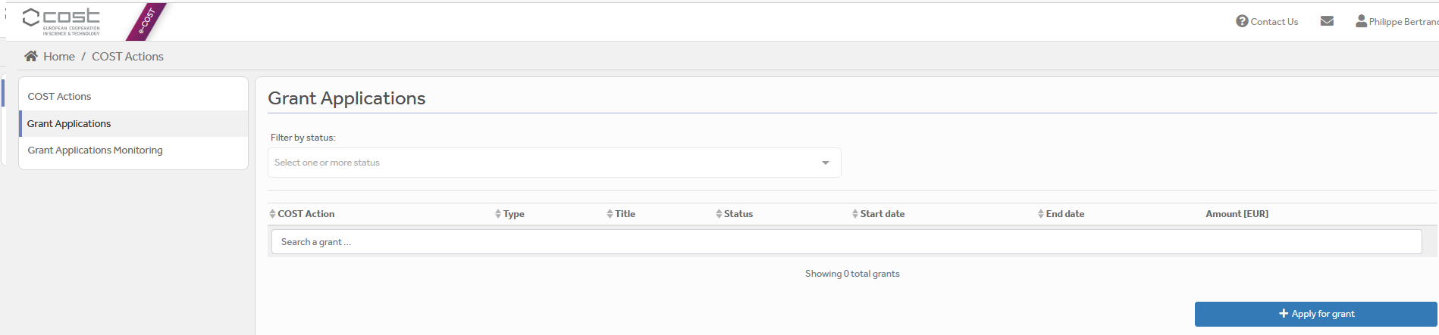

Then click on “Continue” on “VM grant”, to encode a new application.
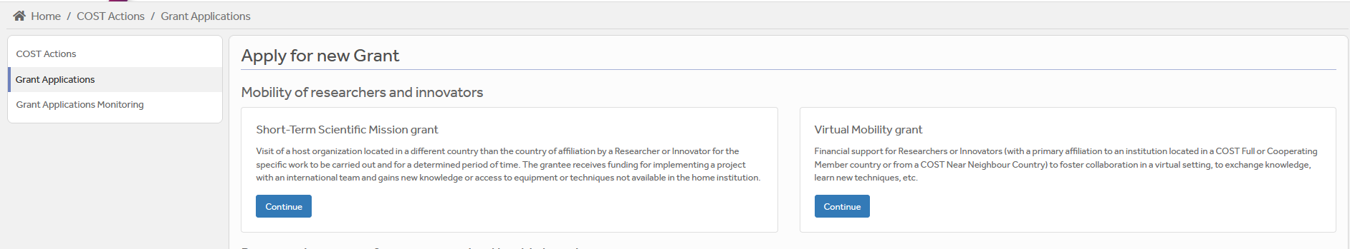

Then you just need to fill the online form with the following information:
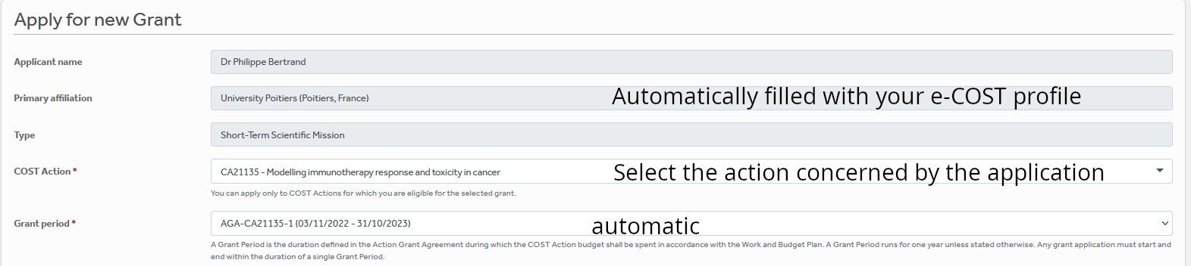
VM

After “Save Draft” you reach the “Supporting documents” page. Here you need to mention the title of the file you will submit, the type and upload the file. Upload all the requested documents that includes:
- The Grant application form,
- The Additional information document (Annex I)
- A CV

Once all the documents are loaded, the applicant should click on “Submit”, a new window will appear and clicking on “Options”, please “download PDF”.

Grant awarding board (GAB)

The GAB is composed of the Grant Awarding Coordinator (Dr. Philippe Bertrand, Philippe.bertrand@univ-poitiers.fr) and representatives of the working groups. It is mandatory to select the working groups the application is related to in the additional information part of the modified grant application template as reviewers of the application will be selected in the same working group(s).

The GAB will perform the scientific assessment of the applications considering the IMMUNO-model Action scope and objectives, as well as the potential for enhancement of the research interaction between the involved parts, measured by the impact of the exchange expected by the applicants and involved institutions.
The selection of applicants is based on the scientific scope of the VM application which must be coherent with the overall objectives of the Action. The GAB will select the successful applications.

In case of conflict of interest (i.e. the applicant belongs to a commission’s research group), the member that is constrained in their duties will be substituted by the Action Chair or the Vice-Chair.

General criteria for evaluation of VM proposals are:
- Gender balance for applicants or within the team the applicant build for the project.
- Quality of the VM project;
- Contribution to the progress towards the Action objectives and deliverables;
- Curriculum Vitae (CV).
- Application between May 1st 2026 – October 31st 2026

The Grant Holder Manager will inform each approved applicant by sending a Grant Letter generated from e-COST.

VM reporting: Scientific Report, and short report for dissemination purposes

VM report – The template provided by COST to prepare your application can be found at www.cost.eu/virtual_mobility_grant_report

Report for dissemination purposes (Annex II) We request the applicant to provide mandatory additional dissemination information in a separate form provided in Annex II to be uploaded separately on e-COST. This dissemination information is mandatory to approve the report. If it is missing, the report will be rejected.

The VM report must be uploaded at the end of the VM, within 30 days from the end date of the VM and before October 31st 2026 via e-COST platform.

Other documents to be provided are
The Additional information document (Annex II)
Any documents or links to numeric materials produced as deliverables during the mission;

The scientific report is drafted by the applicant (max 4 pages).

When preparing the scientific report please consider the following:
- The scientific report for COST is a public document. Please take this into account in terms of Intellectual Property Rights.
- The scientific report does not need to contain specific and detailed results of the research. The report should focus on the networking aspects (e.g. composition of the team built for the mission), in particular how the numeric tools developed will contribute to future collaborative research within the framework of Cooperation and Science in the European Union.
- Any additional information the applicant wants to add should be on a separate document (e.g. calendar of meetings with lists of attendees, data structure generated…)

The short report for dissemination purposes

Using Annex II, please provide a short blog / success story (3-4 sentences) /video (max. 1 minute) describing the subject of your collaborative VM activities including a strong advertising sentence summarizing your VM experience. This material will be used for promotion of our COST Action in our web site and social media. Also include all your credentials in social media (if you have any) to be able to tag you in when publishing your post.

Please remember to present your passion for science! Use pictures showing you at work but also after-work. Do not sound too abstract, avoid scientific jargon, use short sentences. The material is to advertise IMMUNO-model COST research, promote you, and will be shown in social media for public audience.

The material has to be sent directly to Working Group 5 Leader Rosalinda Sorrentino (rsorrentino@unisa.it) within 30 days after the end of your VM and before October 31st 2026.

Failure to submit the scientific report & dissemination materials, and Host acceptance of the Report within 30 days from the end date of the VM and before October 31st 2026 will effectively cancel the Grant.

By applying for this grant, the participant acknowledges that he/she is aware that his/her data and dissemination material will be collected, stored, processed and used for the purposes of the activities of the IMMUNO-model COST Action CA21135 in accordance with the General Data Protection Regulation (GDPR).

VM grant management

Each successful VM applicant will be granted a fixed sum based on the project proposed and expected duration.

*Please note, that in compliance with the Annotated Rules (page 100) the maximum amount that may be reimbursed is up to EUR 1,500 per grant.

A VM Grant is a fixed financial contribution which takes into consideration the project of the applicant and the outcome of the evaluation of the VM application (1500 euros max). Please note that VM Grants do not necessarily cover all expenses related to undertaking a given mission, being only a contribution to the overall work of the Grantee. Applicant should use the Excel tool provided in the modified Grant application form.

Grants are paid by the Grant Holder Institution after the completion of the activity and approval of all required report/documentation. Within 30 days from the end date of the VM or before October 31st 2026, whichever date comes first), the successful applicant must submit the scientific report and the dissemination materials. These documents must be uploaded on e-COST to proceed with the request for payment.

VM contacts

Dr. Philippe Bertrand  CA21135 Grant Awarding Coordinator  Institute of Chemistry for Media and Material  University of Poitiers  4 rue Michel Brunet TSA 51106  86073 Poitiers cedex 9  France  Philippe.bertrand@univ-poitiers.fr | Prof. Dr Leticia Oliveira-Ferrer  CA21135 Action Vice-Chair  Department of Gynecology  University Medical Center Hamburg-Eppendorf  Martinistrasse 52  20246 Hamburg  Germany  ferrer@uke.de

Annex I: e-COST link to application form template and our additional information template

A - Template to prepare the application: https://www.cost.eu/virtual_mobility_grant_application

B - Template for mandatory additional information to be filled in as a separate document and be uploaded on e-COST when applying.
Additional information requested by the Grant Awarding Board for the evaluation process. In case these information are not provided the application can be cancelled by the board.
Working groups in relation to the project [1] [2] [3] [4] [5] (select 2 max)
WG1 – In vitro and ex vivo cancer immunotherapy models
WG2 – In vivo cancer immunotherapy models.
WG3 – Solid tumors.
WG4 – Hematologic tumors
WG5 – Communication, events and partnering with industry.
For objectives of the working groups, please read the Memorandum of understanding: https://e-services.cost.eu/files/domain_files/CA/Action_CA21135/mou/CA21135-e.pdf.
Please include how the planned communication will contribute to the plan of one or more WG(s) of the Action.
Estimated budget plan: The applicant is requested to define a budget to explain the requested amount.
Double-click the table to edit the embedded excel sheet. Fill only greyed boxes. Current data are to illustrate the automatic calculation. (If not working contact Philippe.bertrand@univ-poitiers.fr)

Annex II: e-COST link to VM report template and our dissemination information template

A - Template to prepare the report at : www.cost.eu/virtual_mobility_grant_report

B - Template for mandatory additional information to be filled in as a separate document and be uploaded on e-COST when reporting.

C - Mandatory dissemination information must be sent to Rosalinda Sorrentino (rsorrentino@unisa.it)
Short report for dissemination purposes.
The participant acknowledges that he/she is aware that his/her data and dissemination material will be collected, stored, processed and used for the purposes of the activities of the IMMUNO-model COST Action CA21135 in accordance with the General Data Protection Regulation (GDPR).

Expected dissemination information

Short blog / success story (3-4 sentences)
Pictures of grantee and VM team (screenshots, examples are proposed below)
Credentials in social media (LinkedIn, X, Facebook), if applicable
Link to material to be downloaded (e.g. powerpoint, videos, links to network hub; pictures at high resolution…)

Examples of items:
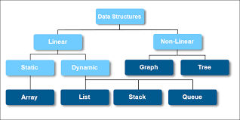
Add caption : structure of the data and their links
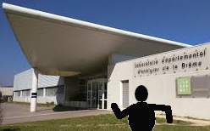  Add picture caption: Myself at institution X…. |   Add caption: Myself giving a seminar/conference/in front of my poster…at …

